The objectives of this tutorial are to practice simulating an ALMA observation, and perform basic imaging with ‘tclean’, in support of an ALMA proposal. For additional guidance on imaging (including self-calibration) please see the many tutorials available here: https://casaguides.nrao.edu/index.php/ALMAguides#Imaging_Tutorials_for_CASA_beginners .

Goal: Determine the required observing time and configuration to image the HD 10647 debris disk in Band 6 (1.3 mm), and then simulate ALMA observations.

Some information on the target:
- RA = 01 42 29.315
- DEC = -53 44 26.99
- Total flux density at 1.3 mm = 6 mJy
- Desired resolution = 0.6’’
- Largest angular scale = 7’’
- Required rms for >10 sigma detection around the entire ring = 14 µJy/beam

Task #1: Use the online sensitivity calculator to determine how long we need to observe with the 12 m array in order to achieve the required rms.

https://almascience.eso.org/proposing/sensitivity-calculator

Required observing time = __________________ hours

Also record the suggested water vapor column density to use in simulations: __________mm

Task #2: Use Table A-1 from the ALMA Cycle 6 Proposer’s Guide to determine the best observing configuration given our desired resolution and largest angular scale.

Best configuration = __________________

Example output from the sensitivity calculator:
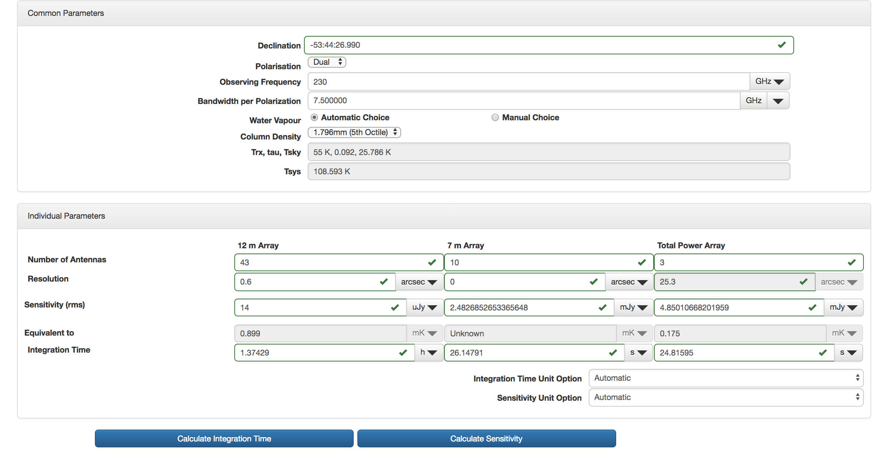

Table A-1 from the ALMA Cycle 6 Proposer’s Guide:
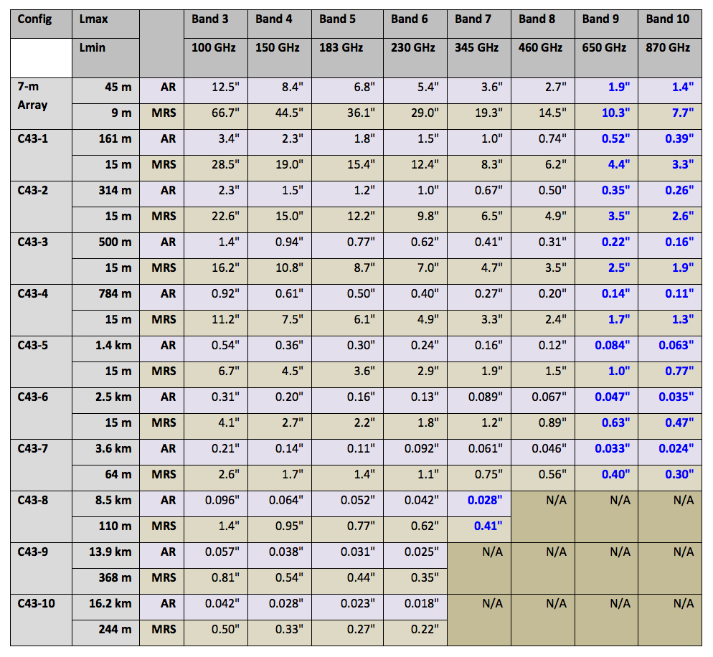

Download the FITS file image of the HD 10647 debris disk to use with ‘simobserve’ :

https://goo.gl/Hnz6Wo

Also download the pointing file ‘ptgfile.txt’. We’ll use this to specify the phase center for our observations, instead of letting CASA decide automatically.

Start CASA and make sure that you are in the directory where you saved the FITS file you downloaded. Then, use
tget simobserve
inp
to list the possible parameters for ‘simobserve’.

Task #3: Set-up ‘simobserve’ to simulate our ALMA observations of HD 10647.
Suggestion: first, try to set the parameters yourself, and then compare with the example below.

Example set-up for ‘simobserve’ in CASA:
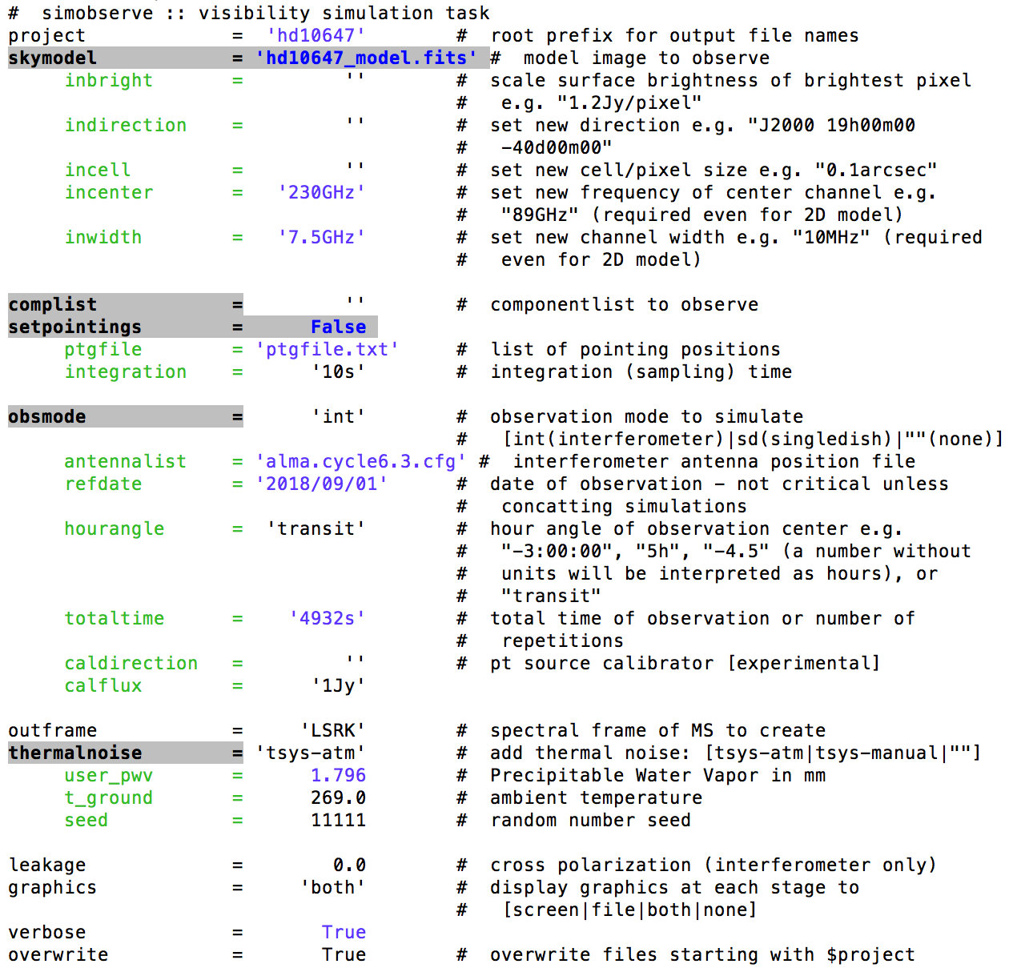

Note: If you downloaded the most recent version of CASA, you should have the Cycle 6 configuration files. But, if CASA can’t find them, you can just use the corresponding Cycle 5 file: ‘alma.cycle5.3.cfg’ (It’s the same!). In the future, you can download the Cycle 6 configuration files using this link:

http://almascience.org/documents-and-tools/cycle6/alma-configuration-files

Task #4: Run ‘simobserve.’ Once you have set all of the parameters, type

go

and then press <enter> to run the task.

Task #5: : Image both the noiseless and noisy measurement sets with natural weighting using the ‘tclean’ task in CASA.
Once ‘simobserve’ completes, move into the project directory to see the output

cd hd10647/

You should have a number of files, including two measurement sets (model visibilities):

hd10647.alma.cycle6.3.ms/
hd10647.alma.cycle6.3.noisy.ms/

The first one does not include model noise and the second one does.

A few questions to keep in mind when defining the parameters for tclean:

- If the expected rms noise in our final image is 14 µJy/beam, what is the right threshold to set for ‘tclean’? _______________ µJy

- What should our cell (pixel) size be if we want to have about 5-6 pixels across the synthesized beam? _______________”

- What size (in pixels) should we make the image if we want to cover the primary beam of the telescope? (Hint: At 1.3 mm, the primary beam has a FWHM of ~23’’)
______________________

Example images from ‘tclean’ of noisy (left) and noiseless (right) measurement sets are shown on the following page. An example set-up for ‘tclean’ in CASA is provided on page 6.

*Bonus Question: What are all of the point sources in the two images above (and in yours!)?

Use ‘imview’ to view your cleaned images. In order to work with your image outside of CASA, you’ll need to export it as a FITS file using the ‘exportfits’ task.

Once you have made natural weight images, try other weighting schemes (e.g. briggs, uniform, and uvtaper) to see what the differences are. You can even try using the ‘imstat’ task to measure the noise level in the images.

