Science case
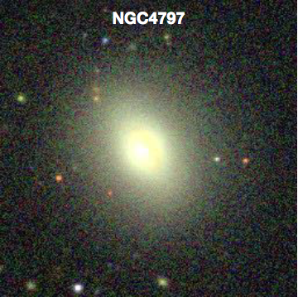
Minor mergers are an important process in galaxy evolution. While major mergers often enhance star-formation, minor mergers have been shown to suppress star-formation (Davis et al. 2015). We will use ALMA to determine the underlying physical cause of this intriguing effect.

This proposal aims to study the gas velocity and distribution in a minor merger remnant (NGC 4797), to distinguish between dynamical suppression, gravitational heating and AGN/starburst feedback. We will also map the dust continuum across the region to reveal the sources of dust heating, and to compare with optically obscuring dust.

Source Characteristics
- Source: NGC 4797
- Coordinates: RA, Dec = 12:54:55.166, +27:24:45.55, z= 0.0262
- Lines of interest: 12CO(1-0) (rest frequency 115.271 GHz), width = 450 km/s
- CO largest angular scale 2’’
- Dust mapping region = 10’’x10”
- Flux: depends on frequency and beam size; see below

Measurement goals
Science Goal 1: Using a single pointing, obtain a spectral line observation of the 12CO(1-0) line at 10 km/s resolution. Additionally, record three continuum bands.
- Desired resolution: 1.5’’
  - Peak CO line flux = 4.6 mJy/beam
  - Continuum emission flux = 0.304 mJy/beam
- Desired LAS: 2.0’’
- S/N=5 on the 12CO(1-0) line -> desired sensitivity per pointing: 920uJy/beam

Science Goal 2: Image the dust continuum in Band 9 at high resolution to match the spatial resolution of existing optical data from the Hubble Space Telescope.
- Desired resolution: 0.05’’
  - Continuum emission flux: 2.0 mJy/beam
- Desired LAS: 2.0”, in a 10’’x10’’ mosaic. Use Nyquist spacing (the default) between the pointings. This is the spacing of samples on the sky needed to get good imaging of large-scale low surface brightness emission. Use the spatial image tool to help you visualize the pointing positions
- S/N=5 in the continuum

