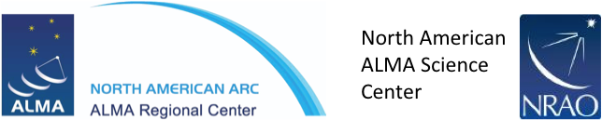

10 October 2016

Development Upgrades of the
Atacama Large Millimeter/sub-millimeter Array (ALMA)

Call for Project Proposals
North American ALMA Development Cycle 5

To Whom It May Concern:

The National Radio Astronomy Observatory (NRAO) invites interested parties in the North American ALMA partnership to submit a Project Proposal(s) for “Development Upgrades of the Atacama Large Millimeter/sub-millimeter Array (ALMA)”.
Complete information and supporting documentation for this Call for Project Proposals can be found at: https://science.nrao.edu/facilities/alma/alma-development-2014/call-for-proposals.
The favor of a reply, in the form of a Notice of Intent to submit a Project Proposal in response to this Call, is requested by 28 October 2016 at 17:00 EST.
Complete proposals submitted by 30 January 2017, 17:00 EST, will receive full consideration. Multiple proposals may be submitted by individual organizations and institutions. Each proposal, however, must comply fully with all of the applicable requirements, including content and submission by the deadline.
Yours sincerely,

Tony Beasley, NRAO Director
Phil Jewell, North American ALMA Operations Director
Al Wootten, North American ALMA Science Center Assistant Director
Bill Randolph, North American ALMA Development Program Manager

