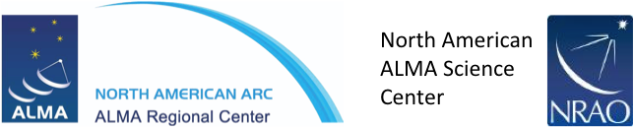
01 March 2017

Development Upgrades of the
Atacama Large Millimeter/sub-millimeter Array (ALMA)

Cycle 5 Call for Study Proposals

To Whom It May Concern:

The National Radio Astronomy Observatory (NRAO) invites interested parties in the North American ALMA partnership and the North American radio astronomy community at large, to submit a Study Proposal(s) for “Development Upgrades of the Atacama Large Millimeter/sub-millimeter Array (ALMA)”.
Complete information and supporting documentation for this Call for Study Proposals can be found at the Cycle 5 webpage.
An informational, pre-proposal meeting will be held on Wednesday, 15 March 2017, from 14:00 to 15:00 EST. Interested parties may attend via teleconference, video-conference or in person at the NRAO Charlottesville Headquarters.
The favor of a reply, in the form of a Notice of Intent to submit a Study Proposal in response to this Call, is requested by 20 March 2017 at 17:00 EST. Please communicate your Notice of Intent via the online form.
Complete proposals submitted by Monday, 01 May 2017, 17:00 EST, will receive full consideration. Multiple proposals may be submitted by individual organizations and institutions. Each proposal, however, must comply fully with all of the applicable requirements, including content and submission by the deadline.
Yours sincerely,

Tony Beasley, NRAO Director
Phil Jewell, North American ALMA Operations Director
Al Wootten, North American ALMA Program Scientist
Laura Jensen, North American ALMA Development Program Manager

