DATA ACQUISITION MEMO # 402

VLBA Thin Tape Recorder Module QA,
Calibration and Support Documents

S. Thompson
August 2002
CONTENTS

INTRODUCTION I

- VME MODULES
  - CLOCK RECOVERY
  - MVME-540
  - VME 117
  - VME TRANSPORT
  - VME WRITE
  - VME MONITOR

- NON VME MODULES
  - PARALLEL REPRODUCE
  - ANALOG CONDITIONER
  - DUAL REEL SERVO
  - HONEYWELL REGULATED POWER SUPPLY
  - INCH WORM CONTROLLER
  - WRITE DRIVER
  - CAPSTAN SERVO
  - READ MODULE
  - M32 PIE TOWN LINK MCB

- SUPPORT TOOLS
  - “MIKE” MODEM
  - VLBA SITE CAPSTAN CALIBRATION
  - CORRELATOR V47C ERROR RATES
  - GRAPHING TAPEPLOT IN EXCEL
  - READBLOCK PROCEDURE
  - VLBA SITE RECORDER SPEED DEPENDENT OFFSETS
  - TAPE LOOP SENSORS
  - VACUUM SENSOR CALIBRATION
  - VLBA TAPE FORMAT AND RECORDING MODES
INTRODUCTION

The VLBA Tape Recorder is currently used to record data in the VLBA format at the VLA and VLBA sites. The PBD version is used to playback sessions to the VLBA Correlator. There are some slight variations in the record and playback units. In order to maintain a standardized performance of all repaired modules, the Recorder Group has put together a compilation of calibration procedures, support tools and QA’s.

In order to perform some of these procedures the user needs a working knowledge of the SCREENS package. The SCREENS package is a computer program used to interface with the VLBA Recorder/Playback units.

There were various contributing authors of these documents. In an attempt to credit everyone who contributed to this project, the following authors are listed.

Steven Durand
Adrian Rascon

Steve Thompson
David McKee
George Peck
J.D. Romney
R.C. Walker
Don Haenichen

Clock Recovery Board (R126) Q.A.
Version 2
January 31, 2001

S/N: ________

Technician: ____________

Visual Inspection

- Look for bent pins, missing hardware, and missing components. _____ (check)

- Make sure all chips and headers are properly seated into board. _____ (check)
Pos.# 1 2 3 4 5 6 7

3. Check DIP Switch for proper setting: 0 1 0 1 1 0 1 (1=on, 0= off) ____(check)

4. Place the board on a piece of foam material to protect the pins on the underside.

Power up test

1. Connect the power cable from the Digital Power Supply to P3 on the VME backplane connector.

2. Turn on the power supply and measure the voltages at the Plus and Minus points on the fuse block and record :

+5 V : ______Volts. (+/- .1v) .

-5.2 V: ______Volts. (+/- .1v) .

3. Turn the power supply off.

4. Remove the 5A slow blow fuse from the +5 volt line on the power cable fuse block.

- Connect an ammeter across the fuse terminal and turn on the power supply.

- Measure the current and record : ______ A ( approx. 1.4 to 1.8 amperes)

7. Turn off the power supply and replace the 5A fuse.
1.1.1
8. Remove the 5A slow blow fuse from the –5.2 volt line on the power cable fuse block.

9. Connect an ammeter across the fuse terminal and turn on the power supply. Measure the current and record : ______ A ( approx. 2.0 to 2.4 amperes)

10. Turn off the power supply and replace the 5A fuse.

Functional Checkout

1. Turn on the power supply. With an oscilloscope probe, check for crystal oscillator operation of all 36 oscillators by connecting the scope probe between each pin on the crystals and ground. The frequency should be 3.579545 MHz.

2. Connect a jumper between pin 39 of J3 and GND on the board. (Enable pin)

3. Setup a signal generator to provide approx. 3.1 MHz squarewave , 50% duty cycle, at 10 volts p-p.

4. Connect an oscilloscope to the test clip provided with power cable.
Channel 1 of the scope should be connected to the white wire on the test clip. (Clock)
Channel 2 of the scope should be connected to the black wire on the test clip. (Data)
The grounds of the probes should be connected to GND on the board.
Set the triggering of the scope to Channel 1. (Clock)

5. Connect the signal generator to pins 1 and 2 of J1.
Connect the test clip to pins 1 and 2 of J2 (Data) and J6 (Clock). Adjust input attenuator on both channels of the scope to 500mv per division.
Adjust timebase of scope to view approx. 2-4 full cycles of the clock signal.
Press the toggle switch on the test clip momentarily to verify proper operation of the differential drivers. The output level should be 1 volt p-p.

1.1.2

The scope screen display should look like the photo below:

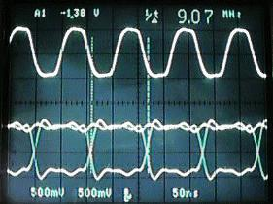

Repeat the above procedure for the rest of the pins on J1, J2 and J6.(up to and including pins 35 and 36 on all connectors)

6. Move the signal source to pins 1 and 2 of J5.Connect the test clip to pins 1 and 2 of J3 (Data) and J7 (Clock).
Repeat the procedure for the rest of the pins on J5, J3 and J7.(up to and including pins 36 and 36 on all connectors)

Error Conditions

Write in any failures in the space provided below.

___________________
___________________
___________________
___________________
___________________
___________________
___________________
___________________
___________________
___________________
___________________
___________________

1.1.3

MVME-540 Analog I/O Board R122
Version 3
November 30, 2000

Calibration Procedure

Jumpers and Switches: 1 2 3 4 5 6 7 8
Set Switch S1 to this configuration: ^ ^ ^ ^ v v ^ ^

——-open———

1 2 3
Set Switch S2 to this configuration: ^ ^ ^

-open-

Assure that all jumpers are configured to the following :

Table 1

J1-A J16-B J27-in J37-out
J2-B J17-in J28-in J38-B
J3-A J18-out J29-out J39-A
J8-in J20-B J30-B J40-A
J9-A J21-out J31-in J41-A
J10-A J22-A&B J32-in J42-A
J12-A J23-in J33-out J43-B
J13-A J24-in J34-B J44-out
J14-A J25-out J35-in J45-out
J15-A J26-B J36-in

J4,J5,J6,J7,J11, and J19 are not used

Programmable Gain Offset
1) Remove all input from JK1 i.e. remove connector from JK1
- Set R64 to center position initially
- Insert Jumpers into J44 & J45
- In MCB Monitor , set address to 2250H
- With a DMM measure voltage between TP2 and TP1 (Analog Ground) and record this value as V1 _______volts
- Set jumpers on J22 to positions E & F

- Measure and record value at TP2 & ground as V0 _______volts
1.2.1

- Calculate offset voltage by the following formula: 1/9*((10*V1)-V0)=Voos
- Adjust R64 until output equals Voos as measured at TP2
- Remove Jumpers J44 and J45
- Reset Jumpers at J22 to A and B

A/D Calibration

Attach cables from break out box to JK1 and JK2 on front panel of the MVME-540

- In MCB Monitor set address to 2250H and set to continuous mode
- Attach a DMM to the test voltage pins on the break out box labeled + and GND.Adjust the + potentiometer on break out box to 9.99 volts.
- Ground input 0 on break out board
- Adjust R3 until all bits are low and LSB toggles between 1 and 0
- Apply 9.99 volts to input 0 on break out board
- Adjust R5 until the 12 least significant bits are on and LSB toggles between 1 and 0
- Repeat above steps several times until both high and low values are toggling the LSB
- With 9.99 volts applied to input 0, go to TDC and type ADVOLT and check status register for 9.99 volts in the first position.
- Step through all 16 inputs and run ADVOLT. Check each position on the status screen to see that about 9.99 volts is displayed in the appropriate position. This checks the MUX circuit.

D/A Calibration

- In MCB command set address to 22D0H (CH#0)
- In TDC type VAC_ 1
- In MCB command set data to 0000H
- Adjust R16 until output is 0.001 volts as measured on the DMM connected between output 0 and ground
- In MCB command set data to 2710H
- Adjust R35 until output is 9.99 volts
- Repeat steps 3 thru 6 until balance is achieved
- In MCB command set address to 22D3H and data to 0000H
- Adjust R10 until output is 0.001 volts as measured on the DMM connected between output 3 and ground
- In MCB command set data to 2710H
- Adjust R27 for 9.99 volts
- Repeat steps 8 thru 11 until balance is achieved
13) In MCB Command set data to 1388H, 09C4H, and 04E2H and check for proper operation of D/A for both channels 0 and 3. See Table 2 on next page.
1.2.2

Table 2

2710H=10000 decimal 10.000 volts
1388H= 5000 decimal 5.000 volts
09C4H= 2500 decimal 2.500 volts
04E2H= 1250 decimal 1.250 volts

1.2.3
VME 117 Check Out
Version 1

August, 2000

VME 117

.

Basic Procedure

Basically the VME 117 board is checked by using the on-board diagnostic software and by performing operational checks with the board in the VLBA drive. The same board is used in both the site recorders and in the playback drives.

Step-by-step Procedure

- Install the VEM board in the drive and turn on the power. Does the green LED illuminate?______
  - Push the RED reset button. Does the green LED illuminate?____
- Initiate the drive and load a tape. Does the bar-code information make it to the setup? ____
- Install the board in a PBD at the AOC. Initiate the drive and load a tape. Set the speed to 158.75. Use the correlator to run error rates. Use the OB2 feature instead of OB1. Verify that the slew function operates properly. The correlator uses the front panel RS-232 port to control the slew. If problems arise investigate the UART chip.
- Check the operation of the clock. Use the SCREEN package to POKE and PEEK into the registers on the VME 117 board.

1.3.1
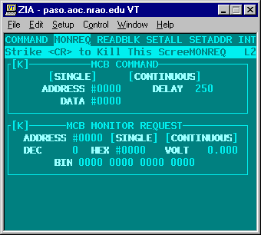

From the VME 117 book the control register is F4C001. Load the E0 and E1 registers by using the MCB command poke.
22E0 – 00F4 and 22E1 – C001
(22XX is for drive #1 2BXX is for drive #2)
From the VME 117 book the “unit Seconds” register is F4C005, ( page 3-6 of the Users manual)
22E0 – 00F4 and 22E1 – C005
Read the register with Monitor Request
2270

1.3.2
VME Transport Module R123 QA
Version 3
January 12, 2001

Visual Inspection

Verify Address #B00 (H) ____ (check)
Verify Identity code #A2 (H) ____ (check)
Verify Interrupt ID #4 (H) ____ (check)
Look for bent pins ____ (check)
Serial # ________
Technician: ______________
Date: ________

MCB Checkout

Install transport card into a card extender. Power up the drive and monitor the following test points with scope:

MCB data in: Point 8003 : 17.5us ____ (check)
MCB data out: Point 7702 : 17.5us ____ (check)
XTAL Osc.: Point 8440 : 11.0 MHz @ 4v p-p ____ (check) ALE Signal: Point 8325 : 540 ns ____ (check)

Capstan Servo Checkout

Initialize and load drive. Set tape speed to 160 ips. Start the tape forward.

Check for Tach from servo signal on pin 7 of P3. The period should be approx. 1870ns., and the duty cycle should be 50%. _____ (check)

Check for Tach to servo signal on pin 9 of P3. The period should be approx. 1870ns. , and the pulse width should be approx. 200ns. _____ (check)

Check for Ref to servo signal on pin 11 of P3. The period should be 15.00 us. , and the pulse width should be approx. 200ns. _____ (check)

1.4.1

Dual Reel Servo Checkout

Check for Take-up low tape signal on pin 13 of P4. Check for Supply low tape signal on pin 15 of P4.These will be low frequency signals with a slow rise time and a fast decay time. _____

Observe that the footage counters in screens are incrementing/decrementing as the tape is moving. _____ (check)

Stop drive and turn off power. Connect scope to pin 7 of P4.Power up drive and observe that the level of the signal is logic high. Initialize the drive and load. Observe that the signal is logic low. This is the system ready signal. _____ (check)

Stop drive and turn off power. Connect scope probe to pin 9 of P4. Power up the drive and observe that the level of the signal goes from logic high to logic low. The brake release will be heard when the signal state changes. _____ (check)

Connect the scope to pin 11 of P4.Type INIT and LOAD. Observe the signal change from logic high to logic low when the vacuum starts to come up. _____ (check)

Inchworm Controller Checkout

In screens bring up the inch test. With the scope connected to pin 5 of P1, tab over to GO and hit enter. Observe, on the scope, very short duration negative going pulses.
Continue to do inch tests and observe similar signals on pins 7, 9, 11, 13, &15.
_____ (check)

Analog Conditioner Checkout

Connect scope probe to pin 5 of P2. Do an inch test and observe the signal toggling between high and low. _____ (check)

1.4.2

VME Write Module QA
Version 2
December 6, 2000

Visual Inspection

Verify Address. #A00 (H) ____ (check)
Look for bent pins ____ (check)
Serial # ________
Technician: ____________________
Date: ____________

Configure the VLB2 Drive

Configure the formatter VLBA 1:1, SRATE 8M, ORATE 9.072M Barrel Roll-OFF. Configure the drive En 1111, Bypass
Select Formatter #1 as data source

Verify the Clock

Monitor the Clock signal on J01 for stability and levels.
Measure the signals differentially using two probes. Set the scope up using Ch1 and Ch2 in the invert and add mode. Trigger the scope with clock signal obtained.

H1G0 HI pin 001
H1G0 LO pin 002 ____ (check)

H1G2 HI pin 040
H1G2 LO pin 039 ____ (check)

Monitor the Clock signal on J02 for stability and levels.
H1G1 HI pin 001
H1G1 LO pin 002 ____ (check)

H1G3 HI pin 040
H1G3 LO pin 039 ____ (check)

1.5.1

Verify the eye pattern

Monitor the Clock and data signals on J01 for stability and levels. Measure the signals differentially using two probes. Set the scope up using Ch1 and Ch2 in the invert and add mode. Trigger the scope with appropriate clock signal, i.e. J01 pins 1 and 2 for low evens, pins 39 and 40 for high evens, J02 pins 1 and 2 for low odds, and pins 39 and 40 for high odds.

Configure the formatter to send a data track to each of the four system tracks, 0, 1, 35, 36. Use SCREEN-RECPARM to select tracks, 0 = 16, 1 = 17, 35 = 18, 36 =19.

Data - Low Evens
Clock - H1G0 HI pin 001
Clock - H1G0 LO pin 002 ____ (check)
Channel 0 Pins 3,4 ____ (check)
Channel 2 Pins 5,6 ____ (check)
Channel 4 Pins 7,8 ____ (check)
Channel 6 Pins 9,10 ____ (check)
Channel 8 Pins 11,12 ____ (check)
Channel 10 Pins 13,14 ____ (check)
Channel 12 Pins 15,16 ____ (check)
Channel 14 Pins 17,18 ____ (check)
Channel 16 Pins 19,20 ____ (check)

Clock - H1G2 HI pin 040
Clock - H1G2 LO pin 039 ____ (check)
Data – High evens
Channel 34 Pins 37,38 ____ (check)
Channel 32 Pins 35,36 ____ (check)
Channel 30 Pins 33,34 ____ (check)
Channel 28 Pins 31,32 ____ (check)
Channel 26 Pins 29,30 ____ (check)
Channel 24 Pins 27,28 ____ (check)
Channel 22 Pins 25,26 ____ (check)
Channel 20 Pins 23,24 ____ (check)
Channel 18 Pins 21,22 ____ (check)

1.5.2

Monitor the Clock and data signals on J02 for stability and levels.
Clock - H1G1 HI pin 001
Clock - H1G1 LO pin 002 ____ (check)
Data – Low odds
Channel 1 Pins 3,4 ____ (check)
Channel 3 Pins 5,6 ____ (check)
Channel 5 Pins 7,8 ____ (check)
Channel 7 Pins 9,10 ____ (check)
Channel 9 Pins 10,11 ____ (check)
Channel 11 Pins 13,14 ____ (check)
Channel 13 Pins 15,16 ____ (check)
Channel 15 Pins 17,18 ____ (check)
Channel 17 Pins 19,20 ____ (check)

Clock - H1G3 HI pin 040
Clock - H1G3 LO pin 039 ____ (check)
Data – High odds
Channel 35 Pins 37,38 ____ (check)
Channel 33 Pins 35,36 ____ (check)
Channel 31 Pins 33,34 ____ (check)
Channel 29 Pins 31,32 ____ (check)
Channel 27 Pins 29,30 ____ (check)
Channel 25 Pins 27,28 ____ (check)
Channel 23 Pins 25,26 ____ (check)
Channel 21 Pins 23,24 ____ (check)
Channel 19 Pins 21,22 ____ (check)

Run Errors Deluxe

Using the Lab Drive run ERRORS DELUX while writing data. Verify the data from formatter #1 is correct by monitoring error rates. ____ (check)

Move the formatter cables from J03 to J07 and J04 to J08. This simulates having Formatter #2 provide data.

Using the Lab Drive run ERRORS DELUX while writing data. Verify the data from formatter #2 is correct by monitoring error rates. ____ (check)

Re-Configure System Tracks
Re-Configure the formatter to send a no data to the system tracks, 0, 1, 35, 36, using SCREEN-RECPARM, 0 = 0

1.5.3

VME-Monitor Module R125

Version 4

March 21, 2001

Serial # _________
Date _________
Technician: _______________

Perform visual inspection of board for any defects, i.e. bent or broken pins on connectors, bent or broken pins on wire wrap side , missing hardware, or ICs. _____ (check)

Insert board into extender card and connect the two ribbon cables (one 40 pin and one 20 pin) to J1 and J5. Power up system. Check for + and – 5 volt supplies at Vee and Vcc pins on board referenced to ground. _____ (check)

In screens get into TDC and initialize the drive by typing INIT.
Set speed to 160 ips.
Type RP 18 18
Bring up the format screen and setup formatter to:

VLBA 1:1 BARREL OFF

SRATE 8M ORATE 9.072 M

Bring up the Tape Recorder Status Screen and change the input to #1.

In TDC type EN 1111 and enter. Type BYPASS and enter.

Connect an oscilloscope to the following points:

Channel A:

Ch 1 to pin 10 of T7032 IC (found at location 6058 on board)
Ch 2 to pin 9 of T7032 IC (found at location 6057 on board)

Set trigger on scope to Ch 1.
Adjust time-base to see approximately 5 to 10 clock pulses.
Measure clock frequency and ascertain that it is 9.072 MHz. _____ (check)
1.6.1
Observe eye pattern on scope. The transitions should occur at the crossover points on the clock waveform. See photo:
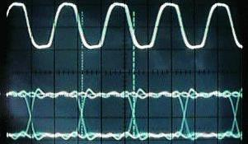

Check Channel B by connecting the scope probes to the following points:

Ch 1 to pin 10 of T7032 IC (found at location 6558 on board)
Ch 2 to pin 9 of T7032 IC (found at location 6557 on board)

Observe eye pattern.

Put Ch2 probe on pin 17 of sync detector chip L10C23 (found at location 4925 on board)
Measure pulse widths of approximately 100ns. The period should be 2.5 ms.

Observe mini-decoder and ascertain that the header information is present. _____ (check)

SYNC WORD

In TDC type GET 0 and observe data: FF7FBFDF _____ (check)
Type GET 32 and observe data: EXXXXXXX _____ (check)

Power the system down. Connect the two ribbon cables to J2 and J7.
Power the system back up.

In screens get into TDC and initialize the drive by typing INIT.
Set speed to 160 ips.
Type RP 18 18
Bring up the Tape Recorder Status Screen and change the input to #2.

In TDC type EN 1111 and enter. Type BYPASS and enter.

Connect an oscilloscope to the following points:

Channel A:

Ch 1 to pin 10 of T7032 IC (found at location 7058 on board)
Ch 2 to pin 9 of T7032 IC (found at location 7057 on board)
Observe eye pattern.
1.6.2

Check Channel B by connecting the scope probes to the following points:

Ch 1 to pin 10 of T7032 IC (found at location 7558 on board)
Ch 2 to pin 9 of T7032 IC (found at location 7557 on board)
Observe eye pattern.

Put Ch2 probe on pin 17 of sync detector chip L10C23 (found at location 4925 on board)
Measure pulse widths of approximately 100ns. The period should be 2.5 ms.

Observe mini-decoder and ascertain that the header information is present. _____ (check)

SYNC WORD

In TDC type GET 0 and observe data: FF7FBFDF _____ (check)
Type GET 32 and observe data: EXXXXXXX _____ (check)

1.6.3
A-33 Parallel Reproduce Module
Version 4
September 23, 2002

Date:
Technician:
Serial #:

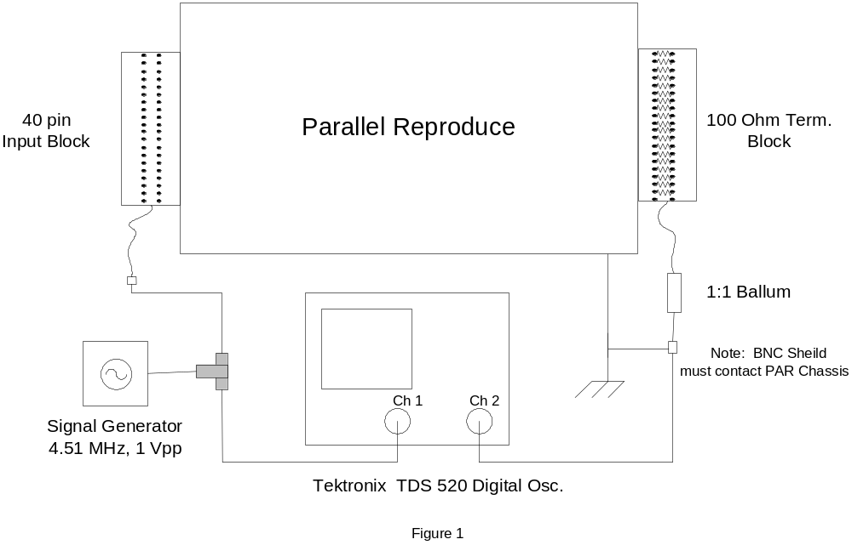

1. Perform a visual inspection. Verify that there is no physical damage, i.e. broken or missing hardware, damaged or broken connectors.
2. Verify that all header modules are present and installed in their proper locations.
3. Connect the unit under test as shown on Figure 1.
4. Apply power to the unit and record the following data:
a) +12 volt supply: _______mA (890 mA typical)
b) -12 volt supply: _______mA (650 mA typical)
.

2.1.1
5. Setup TDS 520 Digital Oscilloscope to handle two signals at 1Vpp @ 4.51Mhz , input should not have any DC offset.
6. One Parallel Reproduce Channel will be tested at one time. By monitoring both input and output take a “snapshot” of the output signal (which is part the “measure” function of the TDS 520 Digital Oscilloscope).

Measurements | 1 / 2 | 3 / 4 | 5 / 6 | 7 / 8 | 9 / 10 | 11 / 12 | 13 / 14 | 15 / 16 | 17 / 18
Freq.
Pk-Pk
(+)Duty
(-)Duty
High
Low
DC Offset

Measurements | 19 / 20 | 21 / 22 | 23 / 24 | 25 / 26 | 27 / 28 | 29 / 30 | 31 / 32 | 33 / 34 | 35 / 36
Freq.
Pk-Pk
(+)Duty
(-)Duty
High
Low
DC Offset

7. Remove Parallel Reproduce from the test setup and install into VLBA Play Back Drive and do error rates, attach copy of Error rates with Test Data.

8. Review Data / Error Rates and correct Track components as necessary.

2.1.2
Analog Conditioner Module - QA Form
Version 6

Start Date: End Date:

Engineer:

Module Name: A11- Analog Conditioner

Serial Number:

Problem Reported By:

Reported Problem:

Power Supply

Voltage Current

Positive Source Vdc Adc +/- 15.0Vdc
Negative Source Vdc Adc

Physical Parameters

- Is the Circuit Board Clean?

- Are Locking Tabs on all connectors?

- Is Front Cover Clean?

Precision Reference

- Adjust R-75 until the voltage at ER MON is -2.73Vdc

________Vdc

2.2.1

LVDT Conditioner

- Ground Pin 5 of BJ2 or Ground the cathode of CR1.

- Ground the input to U3/U1 by grounding the jumper R1/R8

- Adjust R 51/R46 for zero Volts +/- 0.1 Vdc at the output of U12/U11. (easy place to measure the output is on the front side of R40/R32)
Output of U12 Vdc

Output of U11 Vdc

- Ground Pin 5 of BJ2 or Ground the cathode of CR1.

- Connect a LVDT and head to the module.

- Move the Head until the signal at Jumper R1/R8 is about 0.5 Vpp = Vin

- Adjust R11/R4 until the dc voltage at the output of U12/U11 is five times the peak-to-peak input signal, Vout = 5.0 x Vin

(Front side of R40/R32)
Measured Typical
Output of U12 Vdc ~2.5 Vdc

Output of U11 Vdc ~2.5 Vdc

- Adjust the Phase control: Adjust R38/R30 until the waveform at output of U4/U2is centered about either a negative or positive Peak.

- Vary the position of the LVDT and verify the waveform is still centered.
(Back side of R43/R32)

Centered

2.2.2
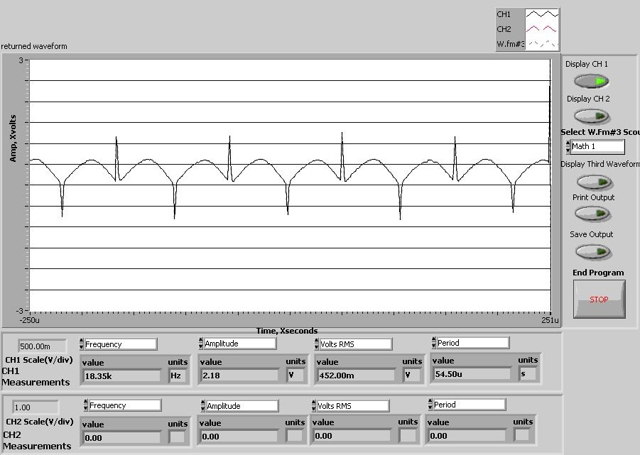

- Ground Pin 5 of BJ2 or Ground the cathode of CR1.

- Ground the input to U3/U1 by grounding the jumper R1/R8

- Readjust R51/R46 for zero Volts +/- 0.1 Vdc at the output of U12/U11.
(Front side of R40/R32)
Output of U12 Vdc

Output of U11 Vdc
13. Remove ground from R1. Readjust R11 until the output of U12 is ~2.5Vdc or slightly above.

Total Power Circuit

- Short the input to ground on the Front Panel BNC labeled "J2 or J3"

- Adjust R113/R109 until the output of U25/U24 is +200 mVdc. If the signal goes negative during normal operation the tape drive produces erroneous readings.
(Back Side of R110/R106
2.2.3

Measured Typical

Output of U25 mVdc +200 mVdc

Output of U24 mVdc +200 mVdc

- Input a small signal on the Front Panel and verify the Gain of the Total Power Circuit.

- Adjust a sine wave signal generator to 0.4 Volts peak-to-peak, 2.5 MHz

- Add 30 dB of attenuation. Inject this signal on the Front Panel BNC labeled "J2 or J3"

- Measure the output of U25/U24 for a signal 5-8 Vdc. Note U25/U24 are design to drive 50 ohm cable so terminate the O-scope to 50 ohms

Measured Typical
Output of U25 Vdc ~ 5-8 Vdc

Output of U24 Vdc ~ 5-8 Vdc

- Check the output of the Pressure sensor. With +15 Vdc input and no differential signal the output is between 1-2 Vdc.

2.2.4
Dual Reel Servo QA Sheet
Version D
March 20, 2001

Start Date: End Date:

Engineer:

Serial Number:

Problem Reported By:

Reported Problem:

Solder all wire terminals

No Power Resistance Test

- Disconnect the leads from TB1 that are connected to the power module heat sink.

- Using a Fluke 87,measure the resistance between the following points:

Black Lead Red Lead East Typical West
Brown Purple 432 K
Brown Yellow 1.9 M
Purple Brown 1.5 M
Yellow Brown 457 K
Yellow Purple 898 K
Purple Yellow 3.0 M

2.3.1

Power Supply

- Use TB1-11 or TB1-12 as a ground reference.

Terminal Measured Typical Value

TB1-9 + 49Vdc

TB1-14 - 49Vdc

TB2-12 - 12Vdc

TB2-13 + 12Vdc

TB2-14 + 4.75Vdc

TB2-15 + 5Vdc

TB2-5 - 6.2Vdc

Physical Parameters

- Is the Circuit Board Clean?

- Are all connectors tight?

- Is Assembly Clean?

2.3.2
Single shot

- Set both inputs to the single shot high and then one at a time force one side low and monitor the result.

Terminal Action QA

J1-7 Connect to +5Vdc
TB2 -7 Connect to +5Vdc
U1 -8 Monitor
Power Up
J1-7 Connect to Ground
U1 -8 U1-8 should start high and go low for 4 seconds

Power Down
J1-7 Connect to + 5Vdc
U1 -8 Monitor
Power Up
TB2 -7 Connect to Ground
U1 -8 U1-8 should start high and go low for 4 seconds

Power Down

Brake Release

- Connect the motor brake leads to TB1 and monitor the driver circuit.

Motor Lead Terminal Action QA
J1-7 Connect to +5Vdc
TB2 -7 Connect to +5Vdc
Black TB1-6 Connect
White TB1-5 Connect
TB1-5 Monitor
Power Up
J1-7 Connect to Ground
TB1-5 TB1-5 should start at 49Vdc, then go to 0.2Vdc for 4 seconds and the brake should click. TB1-5 should then go to about
24.5Vdc.

2.3.3
Power Down
J1-7 Connect to + 5Vdc
TB2 -7 Connect to +5Vdc
White TB1-17 Connect
Black TB1-18 Connect
TB1-18 Monitor
Power Up
J1-7 Connect to Ground
TB1-18 TB1-18 should start at 49Vdc, then go to 0.2Vdc for 4 seconds and the brake should click. TB1-18 should then go to about 24.5Vdc.
J1-7 Connect to + 5Vdc

Loop Sensor Response

- Input a small signal that represents the optical loop sensor output and monitor.

Terminal Action QA

TB2-1 Input a 100 mV, 19.5 Hz (51.1ms) sine wave
Photo A

Terminal Action QA

CR-3 &
CR-4 Monitor for a 800-950 mV, 19.5 Hz sine wave: Vpp

Increase frequency to 100 Hz, adjust O-scope to 100%.
Increase frequency until 70.7% (3 dB point) Photo B

Typical Frequency is about 184 Hz. Hz

2.3.4

Terminal Action QA

TB2-6 Input a 100 mV, 19.5 Hz ( 51.1ms) sine wave
Photo A

CR-12 &
CR-13 Monitor for a 800-950 mV, 19.5 Hz sinewave Vpp

Increase frequency to 100 Hz, adjust O-scope
to 100%. Increase frequency until 70.7%
(3 dB point) Photo B
Typical Frequency is about 184 Hz. Hz

Power Drivers and the Power Circuit

- Simulate the motor load with a 27 ohm 500 Watt resistor. Monitor the current and set the zero.

Terminal Action QA

TB1-7 &
TB1-8 Connect a 27Ohm resistor

J1-7 Connect to Gnd
TB2 -7 Connect to Gnd

TB2-1 Connect to Gnd
TB1-7 Adjust R-72 until the signal at TB1-7 is 0.0 Vdc +/- 10 mV

Vdc

TB2-1 Inject a 750mVpp 10 Hz sine wave
TB1-8 Measure the current waveform across R-57 and compare to Photo C
The steady state current should be about 2 amps.
(0.2Vdc across R-57)
amps

Appropriate Waveform? Yes
TB2-1 Inject a 750mVpp 100 Hz sine wave
TB1-8 Measure the current waveform across R-57 and compare to
2.3.5
Photo D
The steady state current should be about 2 amps
(0.2Vdc across R-57)
amps

Appropriate Waveform? Yes

TB2-1 Inject a 750mVpp 1Hz sine wave
TB1-8 Measure the current waveform across R-57 and compare to Photo E
The current should be a sine wave about 100mVpp across R-57
amps

Appropriate Waveform? Yes

TB1-20 &
TB1-19 Connect a 27Ohm resistor

J1-7 Connect to Gnd
TB2 -7 Connect to Gnd

TB2-6 Connect to Gnd
TB1-20 Adjust R-73 until the signal at TB1-20 is 0.0Vdc +/- 10 mV

Vdc

TB2-6 Inject a 750mVpp 10 Hz sine wave
TB1-19 Measure the current waveform across R-58 and compare to Photo C
The steady state current should be about 2 amps.
(0.2Vdc across R-57)
amps
Appropriate Waveform? Yes

TB2-6 Inject a 750mVpp 100 Hz sine wave
TB1-19 Measure the current waveform across R-58 and compare to Photo D
The steady state current should be about 2 amps.
(0.2Vdc across R-57)
amps

Appropriate Waveform? Yes

TB2-6 Inject a 750mVpp 1Hz sine wave
TB1-19 Measure the current waveform across R-58 and compare to the

2.3.6

Photo E
The current should be a sine wave about 100mVpp across R-57

amps

Appropriate Waveform? Yes

2.3.7

Photo A
100mVpp Input
CR-3,CR-4 output
19.6 Hz

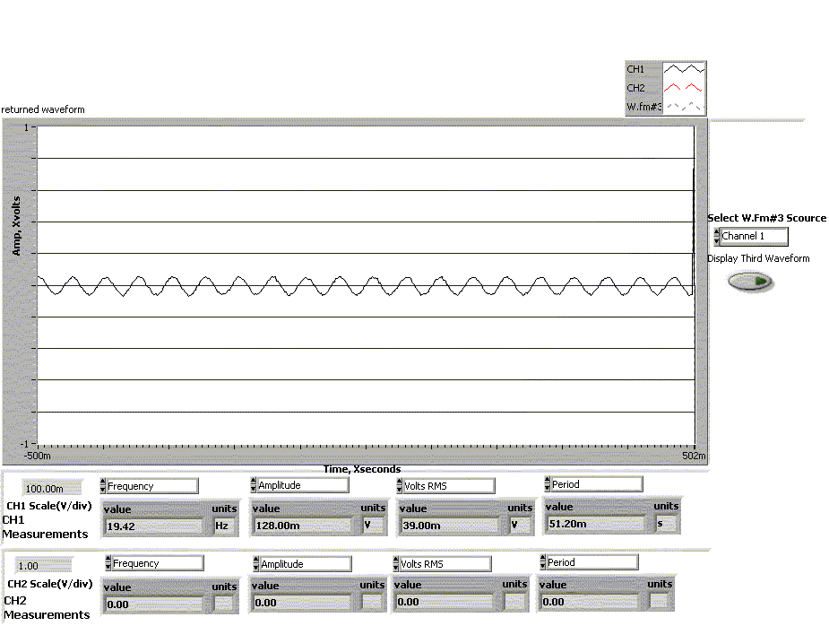

2.3.8

Photo B
3 dB roll-off
100mVpp input
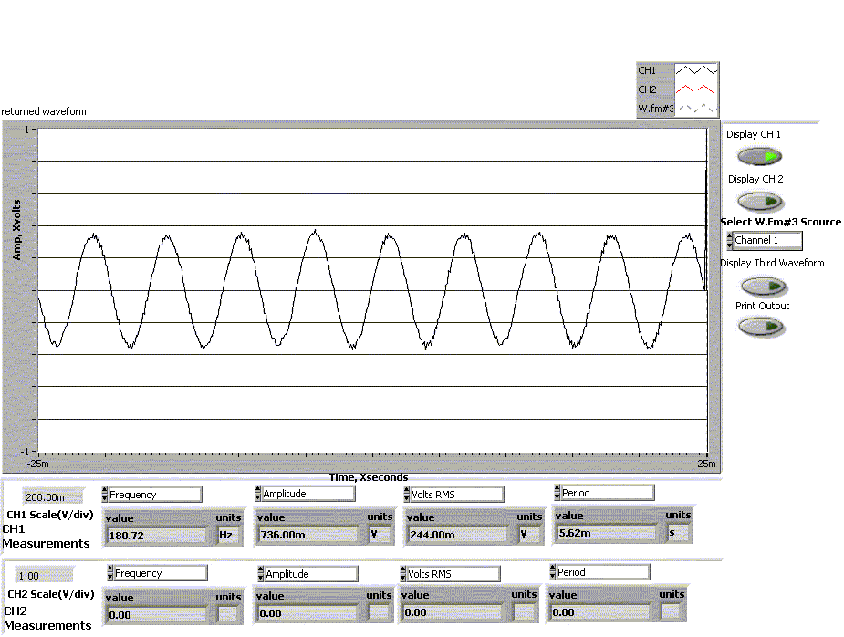

2.3.9

Photo C
750mVpp input 10 Hz
With load resistor
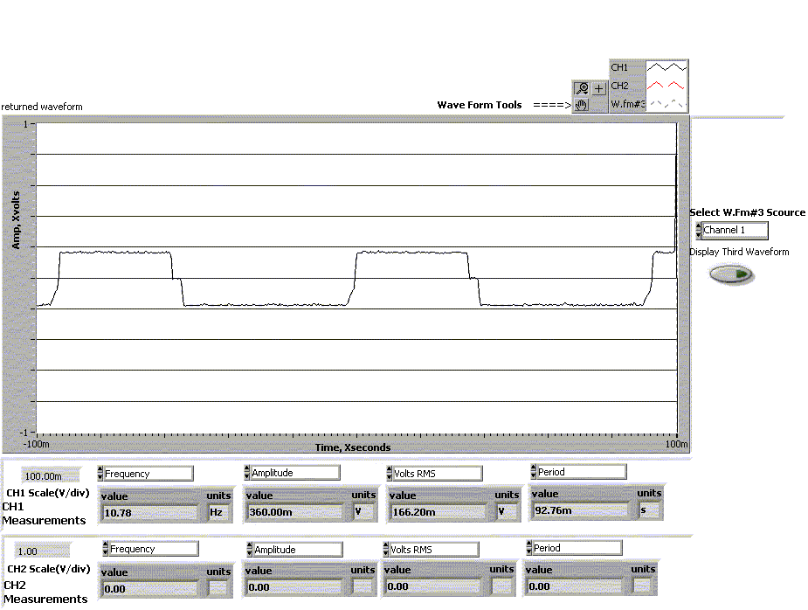

2.3.10

Photo D
750mVpp input 100 Hz
With load resistor

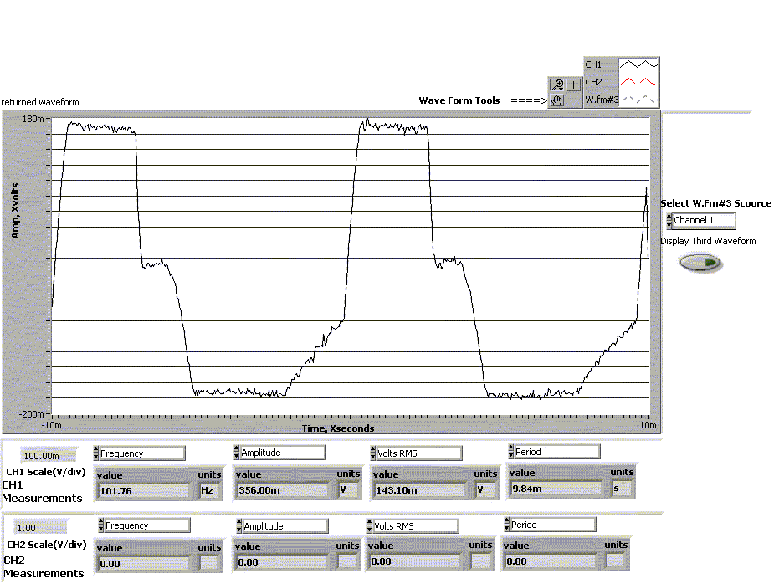

2.3.11

Photo E
750mVpp input 0.1 Hz
With load resistor
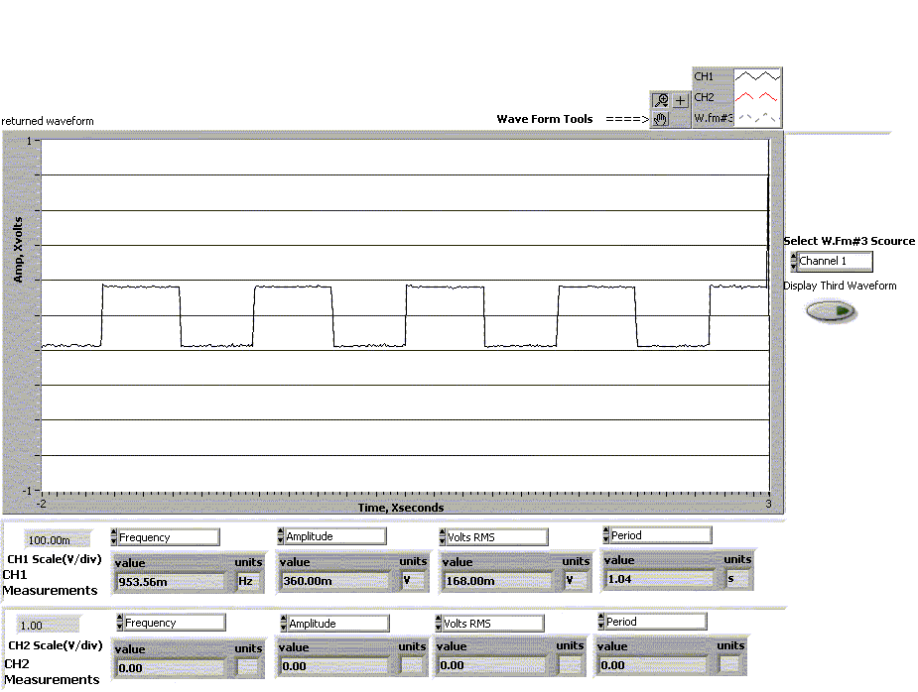

2.3.12
Honeywell Regulated Power Supply
Version 1

Feb, 2002

Start Date: End Date:
Engineer:
Serial Number:
Problem Reported By:
Reported Problem:

Basic Procedure

The Honeywell Regulated Power Supply (HRPS) supplies a regulated + 12Vdc and a + 5Vdc supply. It also provides a switch to the vacuum motor voltage. In addition it provides the voltage and switches to the head and system time meters.

2.4.1

Step-by-step Procedure

Using a DMM measure voltages. In the Test Fixture area there is a cable customized for this application. You will need to set up power supplies that enable you to have + 20Vdc and +11Vdc. Plug the end of this cable into J 1 on the circuit board. Measure –12Vdc at TP 2, +12Vdc at TP 3 and 5Vdc at TP 4. TP 1 is ground.

TYPICAL | MEASURED
TP 2 -12Vdc +.2Vdc
TP 3 +12Vdc +.2Vdc
TP 4 +5Vdc +.2Vdc
- Connect a load, (ie, 10k 1 watt resistor) across TB 1, posts 1 and 3 for –12Vdc, 1 and 4 for +12Vdc and 1 and 6 for +5Vdc. Measure –12Vdc at TP 2, +12Vdc at TP 3 and 5Vdc at TP 4. TP 1 is ground. If voltages are not within + .2Vdc, adjust R1 for +12Vdc, R12 for +5Vdc and R24 for –12Vdc.
TYPICAL | MEASURED
TP 2 -12Vdc +.2Vdc
TP 3 +12Vdc +.2Vdc
TP 4 +5Vdc +.2Vdc
- Connect appropriate regulated voltages to the designated posts on the breakout board. Insert ribbon cable into J3 on HRPS. Measure output of Total System Time, M1. Should be 120Vac. Measure output of Head One System Time, M4. Should be 0Vac.
- On the breakout board connect STOPPED to ground. Measure output of M4. Voltage should be 120Vac.
2.4.2
TYPICAL | MEASURED
STOPPED
Not Grounded 0Vac
STOPPED
Grounded 115Vac +5Vac

Physical Parameters

Is the Circuit Board Clean?

Are Locking Tabs on all connectors?

Is Front Cover Clean?

2.4.3

Inch Worm Module - QA Form

Version 3

CAUTION: This board contains 800 volts. Use high voltage techniques to protect yourself:

- Wear safety glasses.
- Use the One-Hand rule to connect and disconnect the Scope probes.
- Connect the Ac power cord to a switch able terminal strip.
- Use the On/Off switch to remove power between tests.
- Verify that the chassis of the module is grounded.
- Verify that the High voltage 1/8 amp Fuse is installed and good. This fuse connects the transformer high voltage output to the bleed-off resistor.

Start Date: End Date:

Engineer:

Serial Number:

Problem Reported By:

Reported Problem:

No Power Resistance Test

- Measure the resistance from ground to the FETs. Compare the readings to the Attached sheet.

2.5.1

Power Supply

Wire Measured QA

Red 390 Vdc

Red 1640 Vac pp

Blue 17.9 Vac pp

Power Supply from drawing C543065002 (Attached) starting from the upper right hand corner.
Wire | Signal | Ripple | Frequency
Red | 390 Vdc
Red | 1640 Vacpp |  | 60 Hz
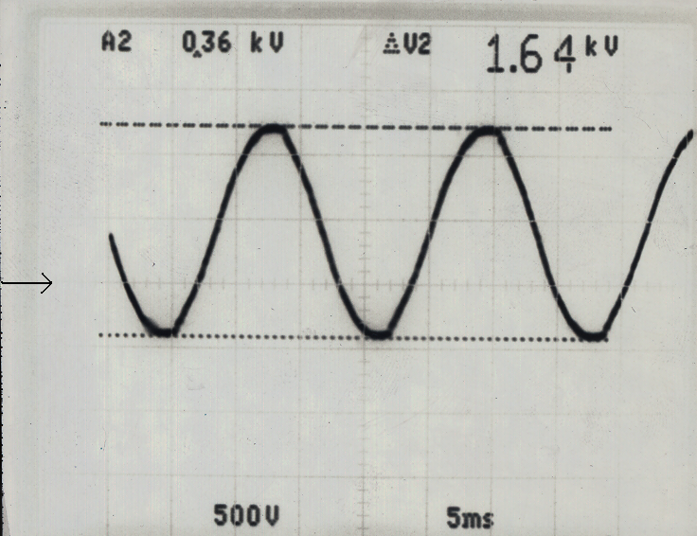
0 Vdc

Wire | Signal | Ripple | Frequency
Blue | 17.9 Vacpp |  | 60Hz

2.5.2

Wire Measured QA

Orange 15.7 Saw tooth
Red/Orange 800 Vac pp

Violet 800 Vdc

Green 5 Vdc

Wire | Signal | Ripple | Frequency
Orange | 15.7p | 4 Vac | 120 Hz
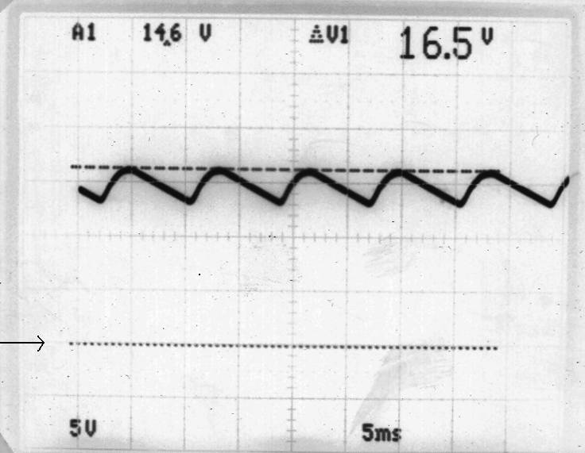
0 Vdc
Wire | Signal | Ripple | Frequency
Red/Orange | 800 Vac pp |  | 60Hz
Violet | 800 Vdc
Green | 5 Vdc | 20 mV

2.5.3

Wire Measured QA

Blue 9 V Saw tooth

Wire | Signal | Ripple | Frequency
Blue | Sawtooth 9 Vp | 4 V | 60 Hz

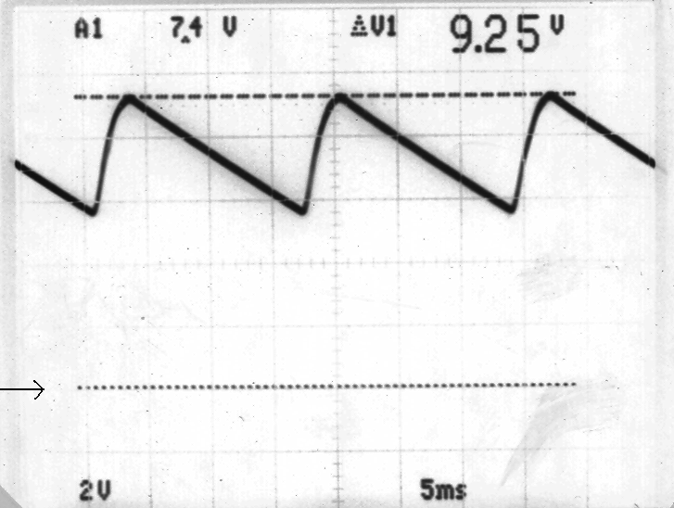
0 Vdc

Physical Parameters

Is the Circuit Board Clean?

Are Locking Tabs on all connectors?

Is Front Cover Clean?

2.5.4

Clock

- Measure Clock Timing.

Pin Measured QA
U22 Pin 7 Slow 185 us
U22 Pin 10 Fast 18.5 us

Clock Source

U22 Pin 7 with slow mode selected
CLK = 5.17 KHz – TTL
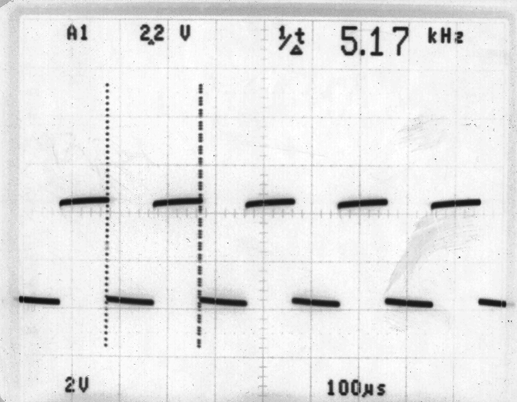

2.5.5

U22 Pin 10 with fast mode selected
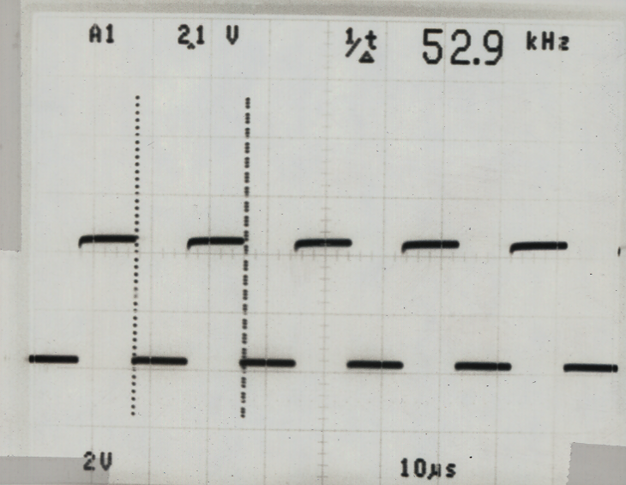

Fast Mode

Pin Measured QA

U35 Pin 15 Fast Pulse Width 9.3 us
U35 Pin 15 Fast Period 4.6 ms

74 ALS 169 Ram Clock: Fast Mode U35 – Pin 15

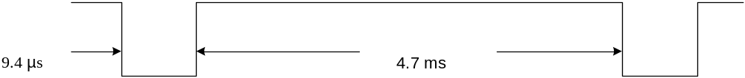

2.5.6
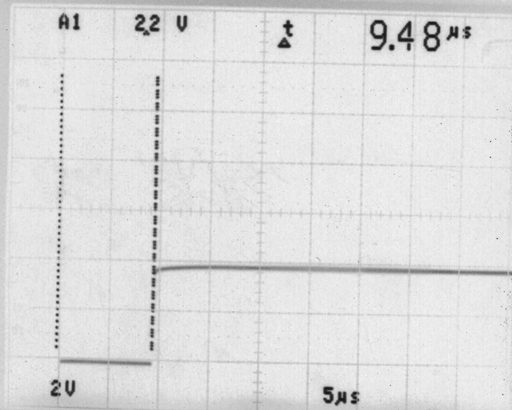

Slow Mode

Pin Measured QA
U35 Pin 15 Slow Pulse Width 92.5 us
U35 Pin 15 Slow Period 47.0 ms

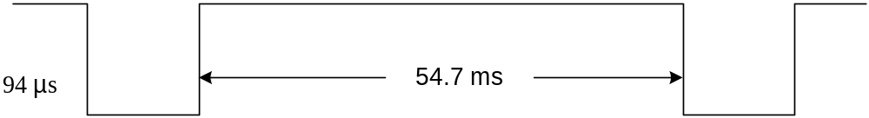

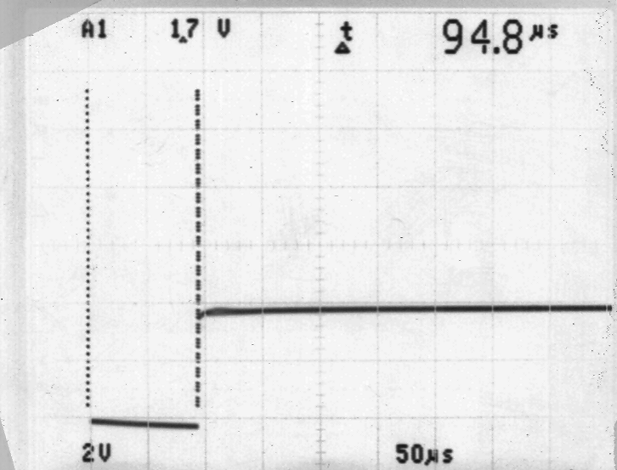
2.5.7

High Voltage Output

Triangle Wave

Measured QA Measured
Channel A Channel B

Slow R121 640 Vpp 10 Hz +/- 30 Volts

Fast R121 640 Vpp 100 Hz +/- 30 Volts

High Voltage Output Waveforms
R – 121 Slow
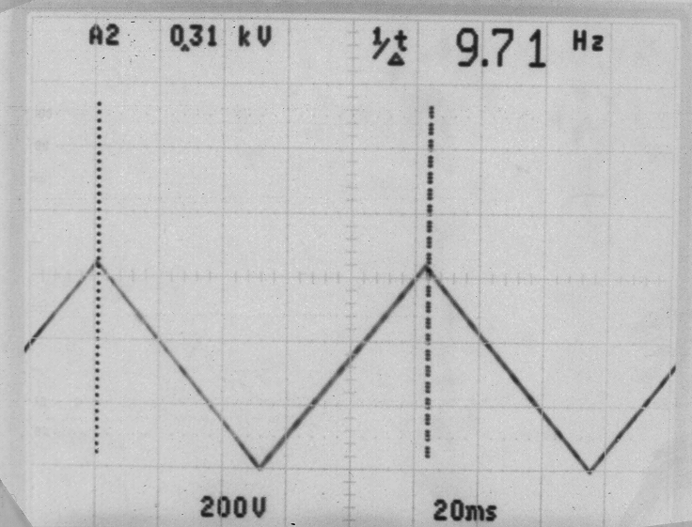
640 Vpp
(645 V +/- 45 V)
R – 121 Fast
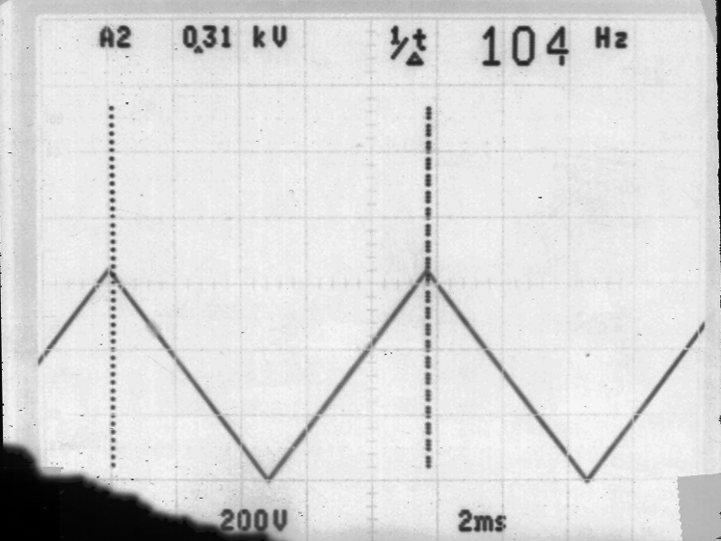
640 Vpp
2.5.8

Square Waves

Measured QA Measured
Channel A Channel B

Slow R131 800 Vpp 10 Hz +/- 40 Volts
Fast R131 800 Vpp 100 Hz +/- 40 Volts

Slow R111 800 Vpp 10 Hz +/- 40 Volts

Fast R111 800 Vpp 100 Hz +/- 40 Volts
R131 and R111 Slow
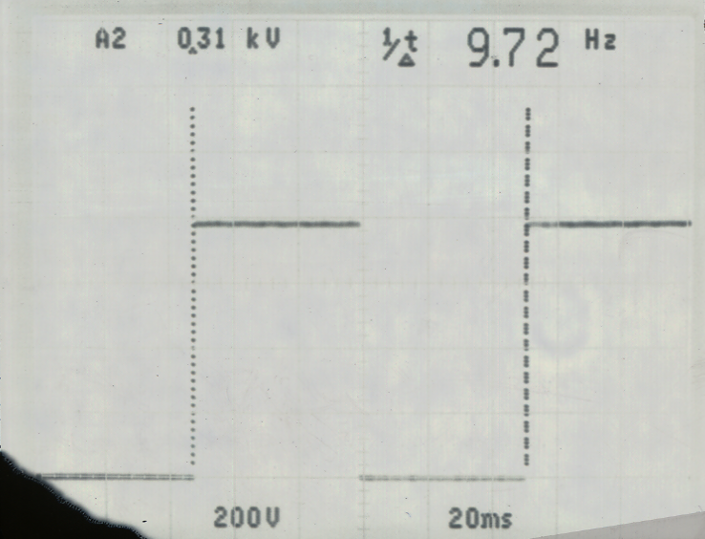
800 Vpp
R131 and R111 Fast
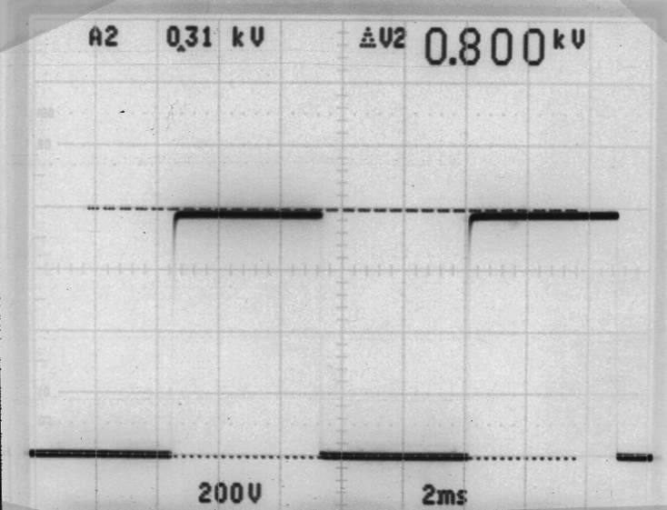
800 Vpp

2.5.9
Bias Voltage

C- 1uF 200 Vdc +/- 10 Vdc

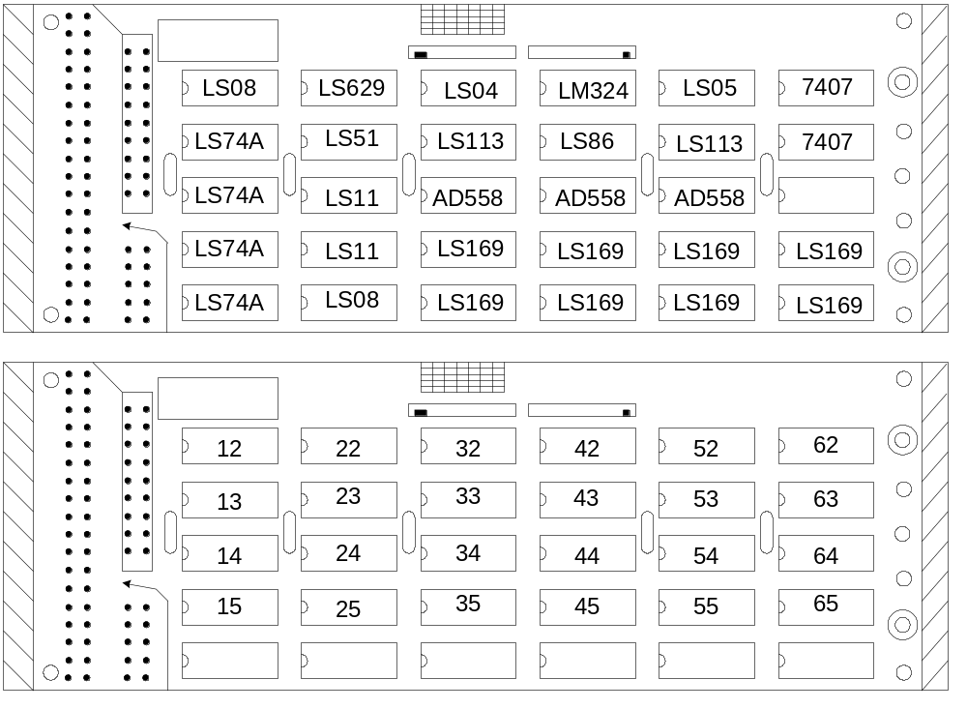

2.5.10
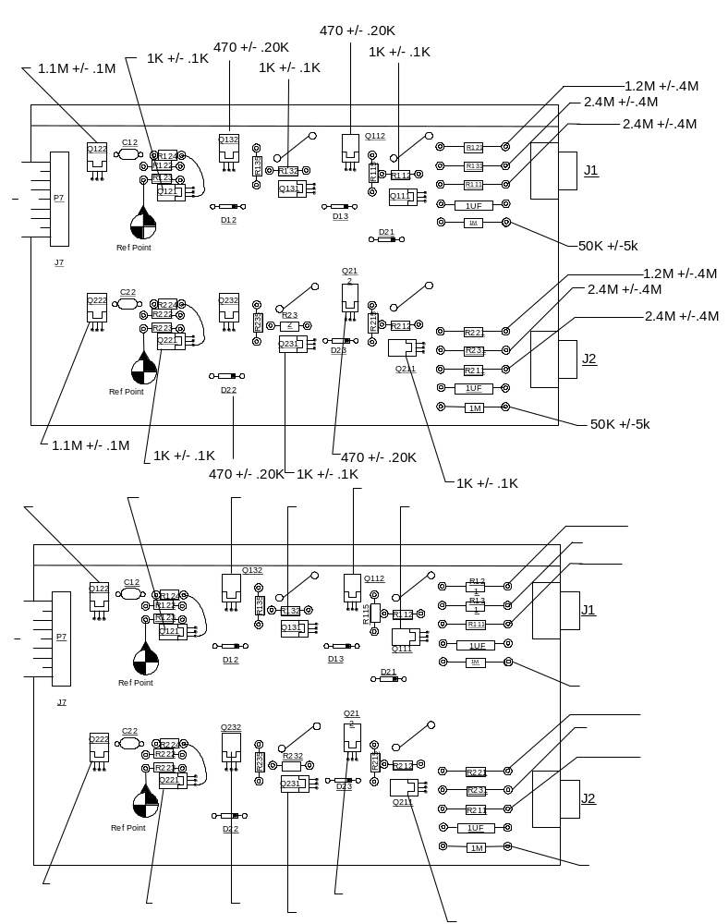

2.5.11
A35 Write Driver Module QA
Version 3
July 18, 2001

Date: ________ QA OK? ________
Technician: ________
Serial #: ________

- Perform a visual inspection. Verify that there is no physical damage, i.e. broken or missing hardware, damaged or broken connectors.

- Connect the unit under test to the appropriate breakout board and terminators outlined in the setup diagram.

- Apply power to the unit and record the following data:

A) +12 volt supply: ______mA (680mA typical)

B) -12 volt supply: ______mA (100mA typical)

C) VR1 output: ______volts (+5.00 volts)

D) VR2 output: ______volts (-5.00 volts)

Write Driver Test

Refer to setup diagram:
- Set the “clock” signal generator to 9.072 MHz.

- Set the “data” generator to 3.5MHz.

- Set the waveform of both generators to squarewave.

- Adjust amplitude of the “clock” generator to TTL level (0 to +5 volts).

- Adjust the amplitude of the “data” generator to 500mV p-p.

- Starting with the ODD tracks, connect the clock signal to pins 1 and 2.

- Connect the data signal to pins 3 and 4.

2.6.1

- On the output side breakout board, connect an oscilloscope to pins 3 and 4.

- Turn on the write voltage supply and set it for 10 volts. Observe the scope trace and measure the peak-to-peak amplitude. The voltage should be 7 volts p-p +/- .3 volts.

- Adjust the write voltage supply from 0 volts to 20 volts.The output should vary linearly from 0 to approximately 16 volts peak to peak. Refer to Typical Scope Pattern on page 3.

- Repeat steps 6-9 for the next 8 tracks.

- At pin position 21-22, connect the clock signal to pins 39 and 40 and check the remaining 9 tracks as per above procedure.

- Check the EVEN tracks in the same manner as for the ODDs.

- When the test is completed, install the unit into the lab drive and perform an Errors Deluxe program to verify that there are no errors.

Begin by setting up the drive as follows:

A) Power up the drive and type INIT and enter.

B) Type EN 1111 and enter.

- Type BY and enter.

- Set speed to 160 ips.

- If the minidecoder does not display time and date, bring up the format screen and and set the formatter for VLBA 1:1, 8M SRATE, 9.072
M ORATE.

- Open the terminal program on your computer and bring up the lab drive.

- Click on OPTIONS and click on MACRO. Double click Errors Deluxe and run the program. After the scan, examine the results for any errors.

2.6.2

Setup Diagram
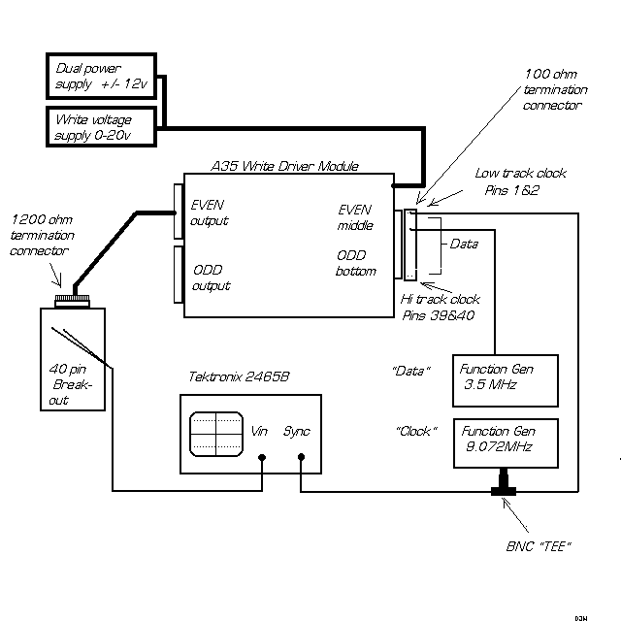

Typical scope pattern

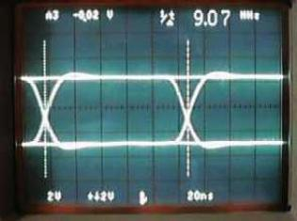

2.6.3
R141 Capstan Servo QA
Version 1
June 21, 2001

Date: _________
Technician: ___________
Serial#: __________

- Perform a visual inspection. Verify that there is no physical damage, i.e. broken or missing hardware, damaged or broken connectors, wires or components.

- Using the lab tape drive as a test fixture, install the capstan servo and connect it to the proper cables.

- Power up the drive and note any unusual behavior, i.e. capstan motor running, capstan servo emitting smoke etc.

- Load the capstan constant test tape onto the drive. After the load sequence is complete, open the drive door and connect an oscilloscope to TP6 and ground.

- Set the speed to 10 ips .

- Adjust R46 (tach gain) CW until the scope trace starts to show excessive jitter. Rotate R46 CCW until the jitter occurs again, then rotate R46 CW 1 turn. There are no other adjustments to be performed.

- Set the speed to 330 ips and check the scope for jitter. Set the speed to 160 ips and check the scope for jitter.

2.7.1
Read Interface Module (R131) QA
Version 2
July 17, 2001

Date: ________

Technician: ___________

S/N: ______

Visual Inspection

- Look for bent pins, missing hardware, and missing components.

- Verify that all headers, and equalizers are seated into their proper locations.

Power Supply

Input Voltages: +12.00 VDC -12.00 VDC

Input current: 200 mA +/- 20 mA ______ mA 200 mA +/- 20 mA _____ mA

Check and record the following voltages:

VR1 (7805) ______ VDC (5.00VDC)

VR2 (7905) ______ VDC (-5.00VDC)

VR3 (7906) ______ VDC (-6.00VDC)

VR4 (7806) ______VDC (6.00VDC)

End To End Test

- Refer to the setup diagram and connect the unit under to be tested.

- Starting with the EVEN tracks, step thru the input pins and address locations and check the response of each with the spectrum analyzer.

- Next, move the input header to the ODD tracks. Repeat the procedure as for the EVEN tracks.
- Place a check mark to indicate acceptance of each track below.
2.8.1

End to End Test - Channel A

EVEN Track # Pins # Address Box # EQ#1 EQ#2 EQ#3
00 3,4 00 _____ _____ _____
04 5,6 04 _____ _____ _____
08 7,8 10 _____ _____ _____
12 9,10 14 _____ _____ _____
16 11,12 20 _____ _____ _____
20 13,14 24 _____ _____ _____
24 15,16 30 _____ _____ _____
28 17,18 34 _____ _____ _____
32 19,20 40 _____ _____ _____
02 31,32 02 _____ _____ _____
06 33,34 06 _____ _____ _____
10 35,36 12 _____ _____ _____
14 37,38 16 _____ _____ _____
18 39,40 22 _____ _____ _____
22 41,42 26 _____ _____ _____
26 43,44 32 _____ _____ _____
30 45,46 36 _____ _____ _____
34 47,48 42 _____ _____ _____

ODD Track # Pins # Address Box # EQ#1 EQ#2 EQ#3
01 3,4 01 _____ _____ _____
05 5,6 05 _____ _____ _____
09 7,8 11 _____ _____ _____
13 9,10 15 _____ _____ _____
17 11,12 21 _____ _____ _____
21 13,14 25 _____ _____ _____
25 15,16 31 _____ _____ _____
29 17,18 35 _____ _____ _____
33 19,20 41 _____ _____ _____
03 31,32 03 _____ _____ _____
07 33,34 07 _____ _____ _____
11 35,36 13 _____ _____ _____
15 37,38 17 _____ _____ _____
19 39,40 23 _____ _____ _____
23 41,42 27 _____ _____ _____
27 43,44 33 _____ _____ _____
31 45,46 37 _____ _____ _____
35 47,48 43 _____ _____ _____
- Compare the measured waveform against the sample waveforms for all 3 EQ settings. All should be within +/- 2dB of the example and each other.
NOTE: Tracks 32, 33, 34, & 35 will be approx. 1.5dB higher than the other tracks.
2.8.2

End to End Test - Channel B

EVEN Track # Pins # Address Box # EQ#1 EQ#2 EQ#3
00 3,4 00 _____ _____ _____
04 5,6 04 _____ _____ _____
08 7,8 10 _____ _____ _____
12 9,10 14 _____ _____ _____
16 11,12 20 _____ _____ _____
20 13,14 24 _____ _____ _____
24 15,16 30 _____ _____ _____
28 17,18 34 _____ _____ _____
32 19,20 40 _____ _____ _____
02 31,32 02 _____ _____ _____
06 33,34 06 _____ _____ _____
10 35,36 12 _____ _____ _____
14 37,38 16 _____ _____ _____
18 39,40 22 _____ _____ _____
22 41,42 26 _____ _____ _____
26 43,44 32 _____ _____ _____
30 45,46 36 _____ _____ _____
34 47,48 42 _____ _____ _____

ODD Track # Pins # Address Box # EQ#1 EQ#2 EQ#3
01 3,4 01 _____ _____ _____
05 5,6 05 _____ _____ _____
09 7,8 11 _____ _____ _____
13 9,10 15 _____ _____ _____
17 11,12 21 _____ _____ _____
21 13,14 25 _____ _____ _____
25 15,16 31 _____ _____ _____
29 17,18 35 _____ _____ _____
33 19,20 41 _____ _____ _____
03 31,32 03 _____ _____ _____
07 33,34 07 _____ _____ _____
11 35,36 13 _____ _____ _____
15 37,38 17 _____ _____ _____
19 39,40 23 _____ _____ _____
23 41,42 27 _____ _____ _____
27 43,44 33 _____ _____ _____
31 45,46 37 _____ _____ _____
35 47,48 43 _____ _____ _____

- Compare the measured waveform against the sample waveforms for all 3 EQ settings. All should be within +/- 2dB of the example and each other.

2.8.3

R121 Read Module Test Setup Diagram

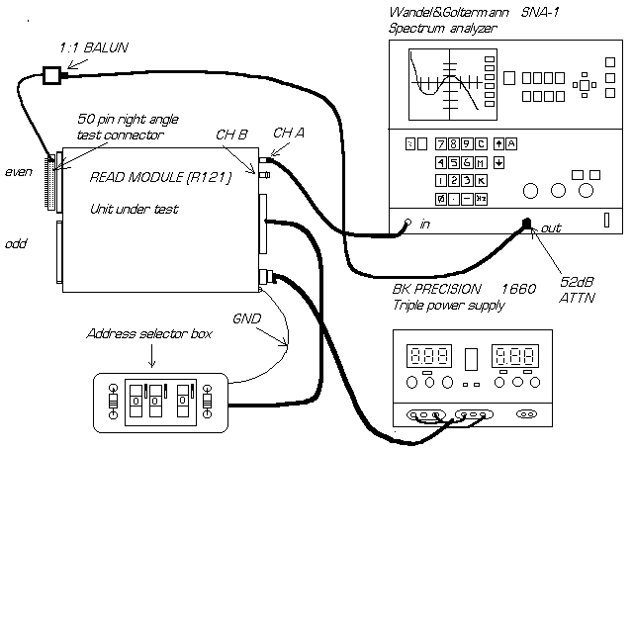
Use recall # 9 on the spectrum analyzer to setup for this test.

2.8.4

EQ 160 Waveform

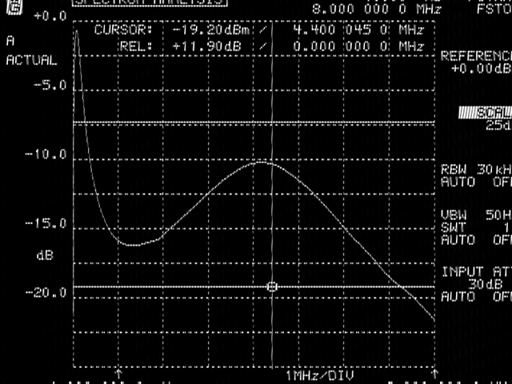

2.8.5

EQ 135 Waveform

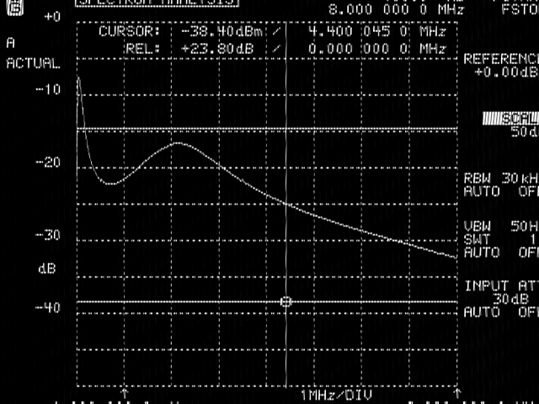

2.8.6

EQ 270 Waveform

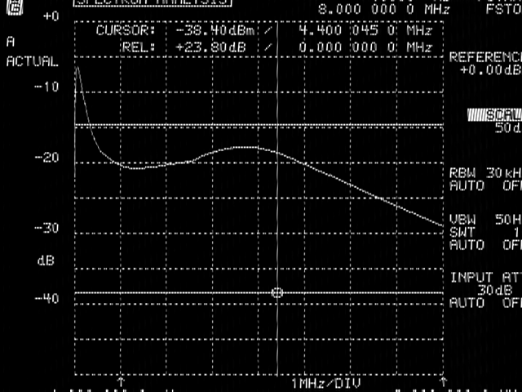

2.8.7
M 32 - QA Form
Version 1

Caution: Invisible laser radiation is emitted from the end of fiber or connector. Avoid direct exposure to beam. Do not view beam directly with optical instruments.

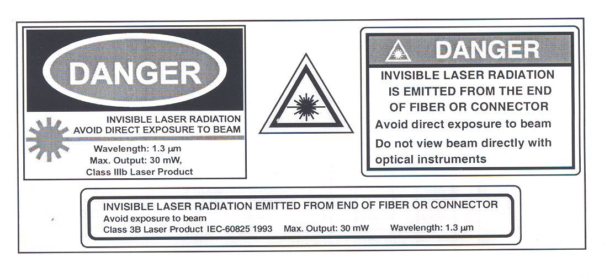

Start Date: End Date:

Engineer:

Serial Number:

Problem Reported By:

Reported Problem:

2.9.1

Voltage Power Supply Measurement

- Setup three power supplies.

a) +5 Volts
b) -15 Volts
c) +15 Volts

- Apply the power to the module using the blue AMP connector

Label | Measured | Typical | QA
5 Vdc | Vdc | 5 Vdc +/- 0.1 Vdc
+15 Vdc | Vdc | 15 Vdc +/-.1 Vdc
-15 Vdc | Vdc | -15 Vdc +/-.1 Vdc

Power supply current measurement

Label | Measured | Typical | QA
5 Vdc |  | 1.7 Adc
+15 Vdc |  | 22.0 mA dc
-15 Vdc |  | 22.0 mA dc

2.9.2

Switch Configuration

 | SIGNAL | ON “0”/  OFF “1”
S1-1  S1-2  S1-3  S1-4  S1-5  S1-6  S1-7  S1-8 | HCLKON  LOOPEN  DIV0  DIV1  FLAGSEL  M20SEL  EQEN  CAV | OFF  ON  OFF  OFF  ON  ON  ON  OFF | Divided high speed clock monitor output (“on” to pwr save)  Local loopback disabled  Use 7.5-11.25 MHz XTAL  Use 7.5-11.25 MHz XTAL  Ignore extra flag bit  16 bit wide data bus selected  Cable equalization D-OUT disabled  Bits on Data input are sent as Control Frame with active low, i.e. 0

2.9.3

Bi-Phase Input Level

- Monitor TP 1 while adjusting R 17.

Signal | Monitor Point | Typical | Measured | QA
Input Level-R 17 | TP 1 | 1.0 Vdc

Bi-Phase Output

- Monitor the output of the buffer drive.
- Adjust for 2Vp-p.
- Ground centered at output.
- Adjust R 20 and R 15 with respect to ground.

Signal | Monitor Point | Typical | Measured | QA
Zero Adj-R 20 | U 9-Pin 11 | 0.0 +/-.01Vdc
Gain Adj-R 15 | U 9-Pin 11 | 2 Vp-p +/-0.1Vdc

2.9.4

Digital Frame
0 Vdc

- Attach one end of a fiber optic cable to the laser output on the back of the module.
- Connect the other end to the input of a 10dB attenuator.
- Connect the output of the attenuator to the receiver input on the back of the module.
- Power up the module using all the proper safety procedures.
- Monitor data signal at DOUT(-), J-3 on the digital board.
- Trigger oscilloscope on pin 3 of jumper JP-2, Frame Clock. Signal should appear as shown in figure 1. This is the output of the HDMP-1022 transmitter chip.

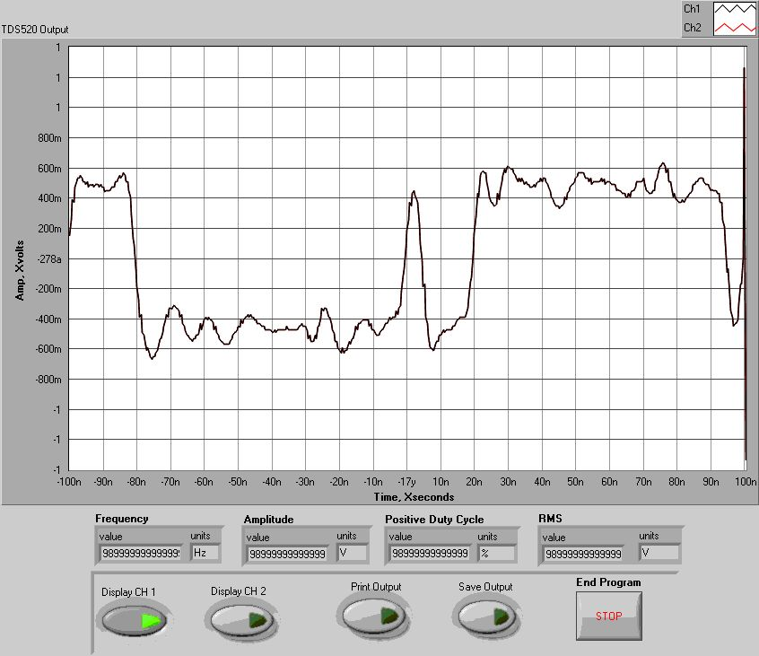
Figure 1 Typical Frame With No Data
2.9.5

- Attach a signal generator to J-1 Pin-3 (D-0).

- Adjust signal generator to produce a TTL signal at 1 Hz. This will toggle D-0 in the frame. See figure 2.

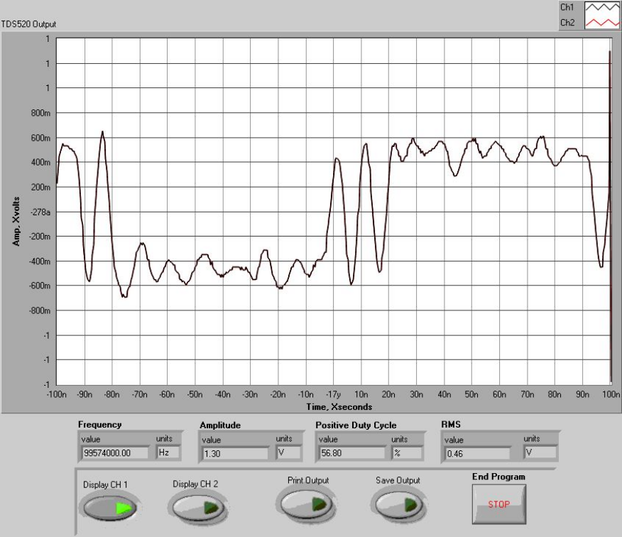

Figure 2 - Frame with D-0 High

Fiber Transmitter / Receiver Board

1. Verify that the same signal is present on the input to the 1024 receiver chip. A convenient location to probe for this signal is on the input capacitor C-5.

Physical Parameters

- Is the Circuit Board Clean?

- Locking Tabs on all connectors?

- Is Front Cover Clean?

2.9.6
DIGITAL TRANSCEIVER MODULE – M32

A digital transceiver module consists of two cards, the G-link card and the fiber optic modem card. A digital transceiver module is required at each end of the PT link for transmission of VLA waveguide synchronization, noise diode and Monitor Control System data and other miscellaneous signals if desired.

The G-link Card

The G-link card uses the LSI Hewlett Packard HDMP-1022 Tx and HDMP-1024 Rx, 80 pin Mquad chip set pair. The Basic Tx function is to time multiplex a 16bit wide parallel loaded word into a f_{clock} x 20 serial ECL bit stream (nominally 200Mbit/sec). The Rx function is the inverse operation.

By using 2 G-link transceiver cards separated by transmission line, a point to point “virtual ribbon cable” is created.

The LSI chips hide much complexity from the user.

The Tx chip provides
- Parallel Word Input
- High speed clock multiplication
- Frame encoding
- Parallel to serial mux
- ECL outputs

The Rx chip provides
- Clock recovery
- Data recovery
- Demux
- Frame decoding
- Frame synchronization
- Frame error detection
- ECL input

The DC balance of the line code is automatically maintained by the chipset.

In the M32 the G-link circuit is hardwired in a full duplex configuration, handling all the issues of link start-up, maintenance and simple error detection required of a bidirectional system. An important repercussion of this is both directions of the digital link MUST be operational for the system to start-up.

2.9.7

Some simple options are configurable on board by S1- refer block diagram.

For normal operation 16bit mode is selected, hence only D0 to D15 is used in operation. D0 is the antenna or central buffer I/O. The D0 line on the Rx chip has attached interface circuitry for the VLA style AB or CB. It removes the DC component from the waveform as well as provides the nominal 2vpp waveform required.

A great versatility of the G-link configuration is the asynchronous transport of signals from point to point when signal are derived from clocks of varied origins. A small jitter of 1/(2f_{clock}) is added to each line D0-D15. For transfer of data in the kilohertz range the effects are negligible.

As the G-link chip sets are quite complex, further operational details are available in the HP design document (5966-1183E 9/97)

Digital Fiber Optics Modem Card

The ECL compatible D_{out,} D_{in} signals from the G-link cards are only intended to drive short sections of copper cable. To utilize the 104km fiber to PT a fiber optic transceiver card is required with particular optical requirements needed for DWDM.

As the bi-directional link has to work on a single fiber, each direction is confined to a specific optical channel of the 1550nm ITU grid:

- PT to the VLA at 1530nm, VLA to PT at 1535nm.

The laser transmitter is a directly modulated design. The laser diode submodule exhibiting low wavelength chirp characteristics for 2.5Gbit/sec in 2000ps/nm high dispersion fiber. For operation at 200Mbit/sec chirp effects can be ignored. As with many telecommunication DFB laser submodules the packages are common anode. Mechanical mounting and proper thermal dissipation fixes the case at 0vdc or chassis GND. In order to use this a negative bias is required on the cathode of the DFB. The MAX3667 SONET laser driver IC with Automatic Power Control is used with the usual IC Vcc made chassis GND and the IC gnd made –5vdc.

Two adjustments are required to set the fiber modem card. The modulation depth is set by Modset (50k pot) and adjusts the peak-to-peak power excursion with modulation. The average optical power is determined by the Apcset (50k pot). A combination of the two adjustments will maximize the distinction between an optical “1” and an optical “0”, thus optimizing the extinction ratio.

Although modulation and bias current mirrors are available and scaled currents can be calculated by measuring the differential voltages (use isolated CRO as –5vdc is now “GND”) across the modmon and biasmon resistors the more definitive adjustment uses the M32 in loopback. 2.9.8

By using the G-link card or G-link evaluation Tx card to supply a DC balanced bit stream to the fiber transceiver and looping the fiber Tx port back to the fiber Rx port via a 26dB attenuator or better still 104km test spool, adjust the Modset and Apcset trimpots for optimum eye pattern opening and minimal jitter. In practice this will NOT correspond to maximum laser optical power due to MAX3667 limitations on modulation depth and heat dissipation. Optical output powers of 0dBm were found to provide best eye-pattern results.

A crucial adjustment is that of laser wavelength. The optical wavelength must be set precisely within the transmission window of the fixed DWDM filter channel. Wavelength adjustment can only be effected by DFB temperature. Wavelength Electronics Corp PID control module HTC1500 provides exceptional thermal regulation. There are two adjustments on the HTC1500. The current limit should be set to 1amp, use a 20k trim pot adjusted to 10k to simulate the DFB thermistor and 2R2 ohm resistor to simulate the Peltier cooler. Adjustment of the 10K above and below T_{set} (~1000mV) will either heat or cool (i.e. fwd or reverse the current in the 2R2 load).

With the actual DFB installed the T_{set} monitor voltage should be 1000mV +/- 50mV. The T_{monitor} should equal the T_{set} within minutes of power up. Note the DFB thermistor has a negative slope, thus an increase in package temperature will correspond to decrease in T_{monitor .} T_{monitor} should not drop below 950mV.

The optical Rx segment is essentially an ECL buffered submodule. The footprint corresponds to a SONET standard and is available from several vendors. The Rx module contains the PIN Rx diode, AGC and limiting amplifier. Laser Diode Inc can supply a plug in replacements for 52, 155, 622 Mbit/sec modules.

In the current scheme the 155Mbit/sec unit works well with an average light level of –38dBm. Typical receive light levels are –22dBm, a healthy 16dB link margin assures reliable operation.

For operation at 622Mbit/sec a negative 5vdc is recommended on the PIN diode to enhance bandwidth.

2.9.9
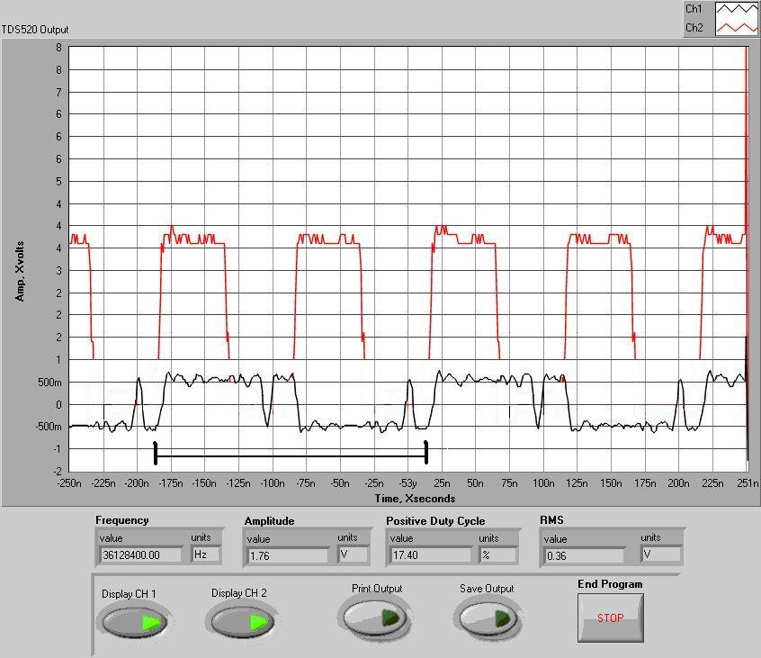

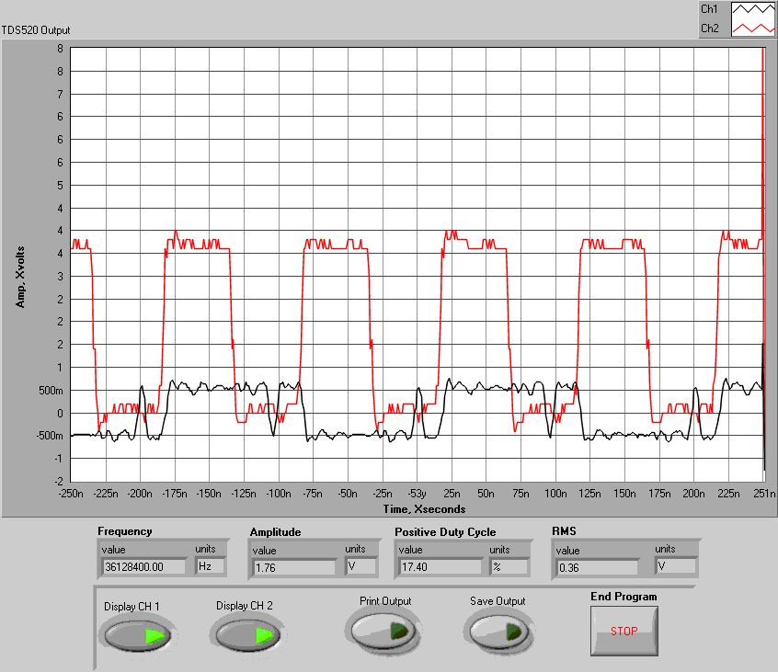

2.9.10

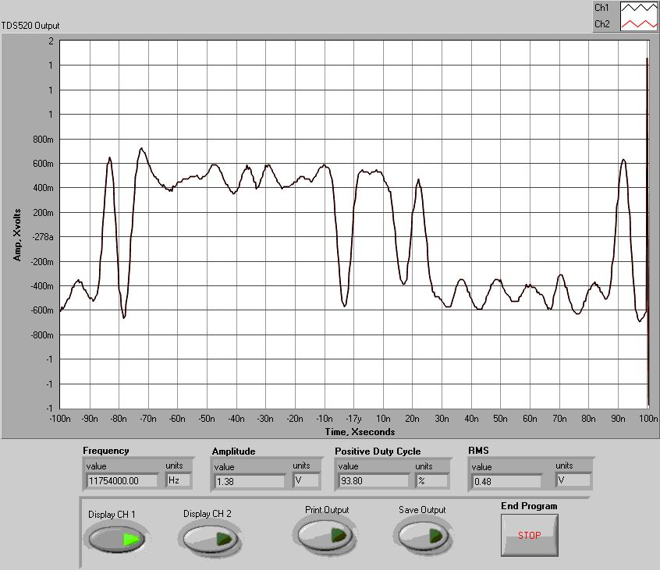

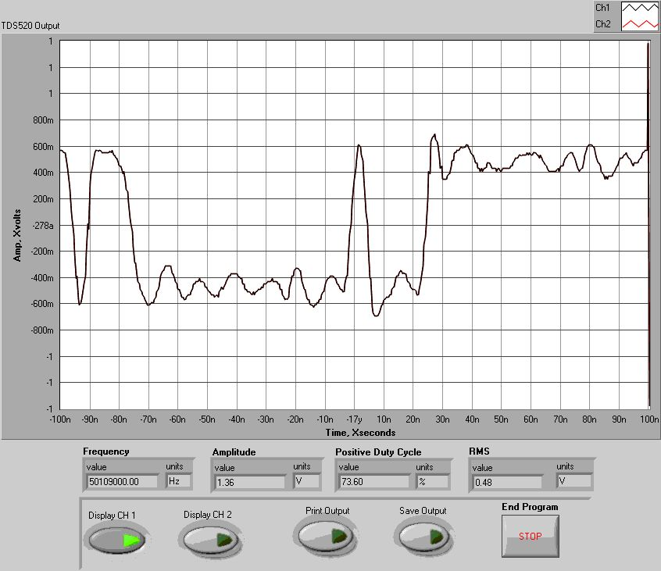
2.9.11
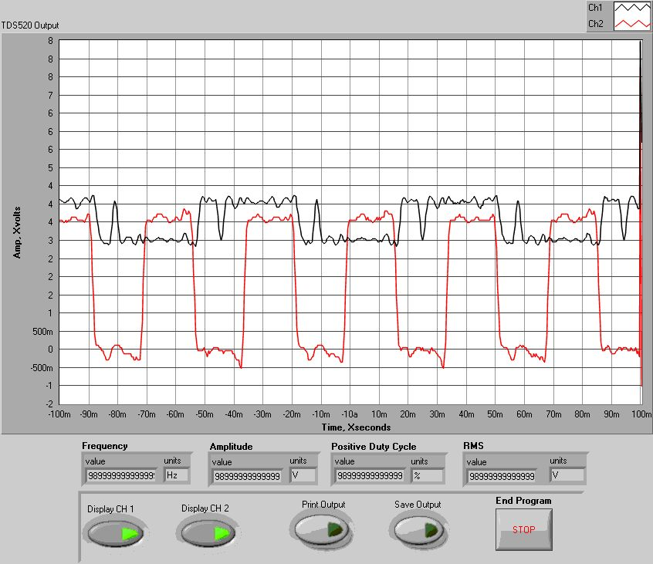

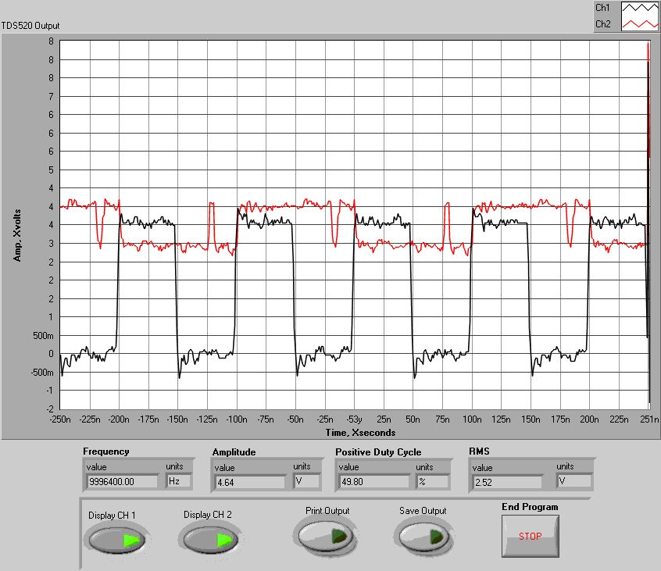

2.9.12

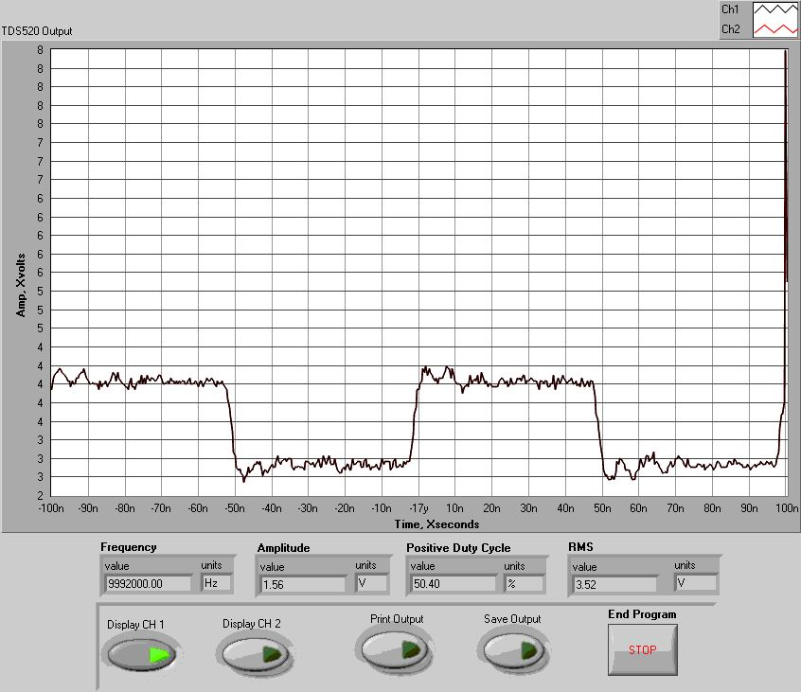

2.9.13
Laser Frequency Adjust

- Use the Ando AQ-0315A Optical Spectrum Analyzer.
- Press “auto.”
- Connect output of laser directly to analyzer input. No attenuation is necessary.
- Adjust R-65 (laser temperature adjust) for the PT module center. Frequency should be 1530 nm.

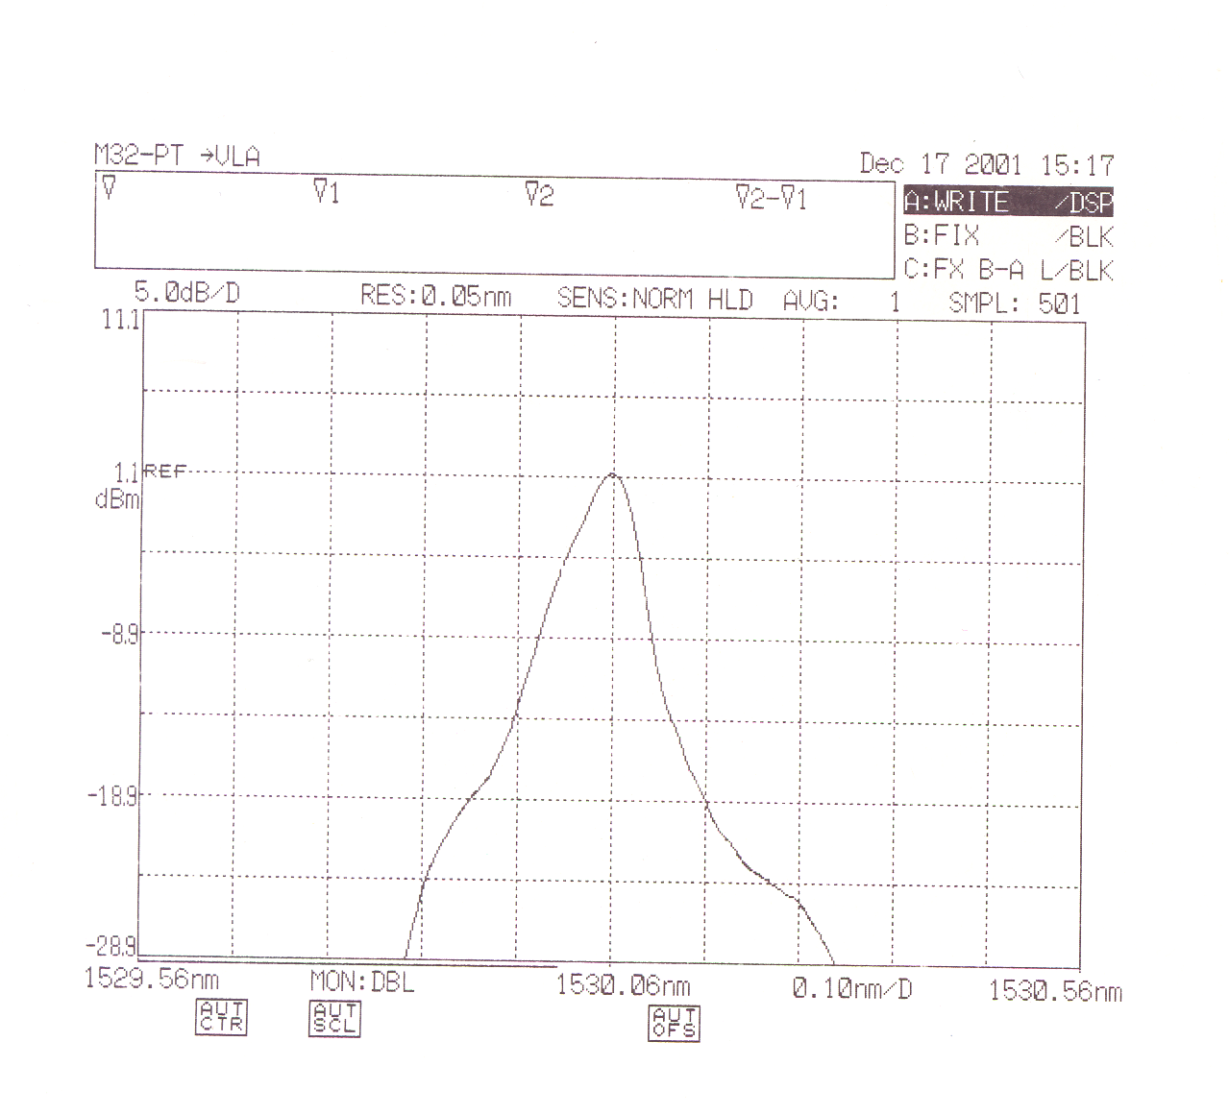

2.9.14

- Use the Ando AQ-0315A Optical Spectrum Analyzer.
- Press “auto.”
- Connect output of laser directly to analyzer input. No attenuation is necessary.
- Adjust R-65 (laser temperature adjust) for the VLA module center. Frequency should be 1535 nm.
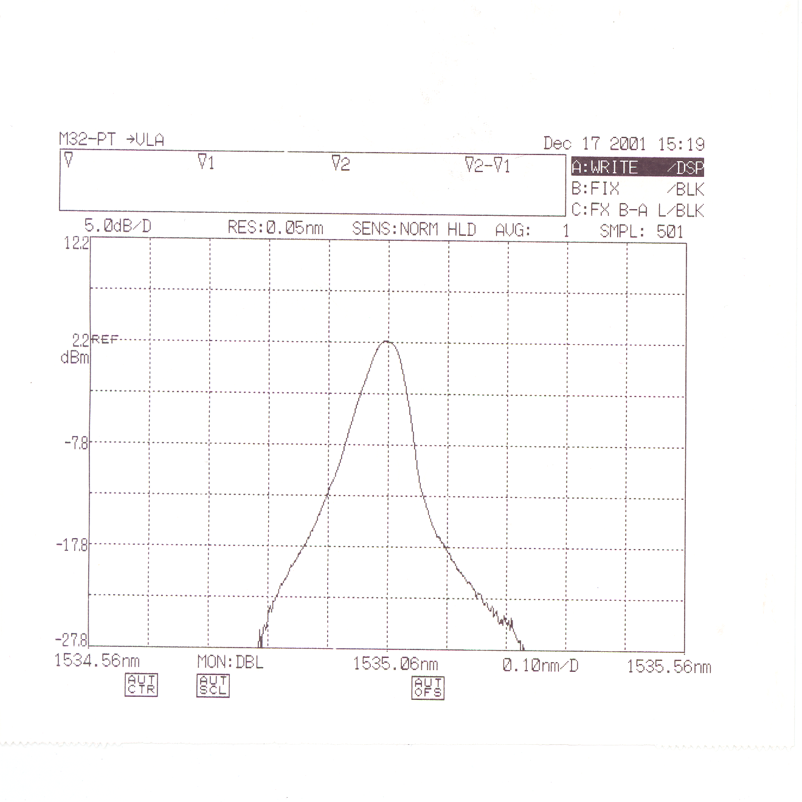

2.9.15
AOC Server and VLA Server “MIKE” MODEM Usage Summary

Log in

- Go to START/RUN/Telnet zia

- Login as per usual with your Unix login name and password.

- Then Type in: “telnet aocserver” or “telnet vlaserver.”

- At the “USERNAME” prompt on servers: Type in your username.

- At the “PASSWORD” prompt on servers: Type in your chosen password.

Accessing modem
1. At the aocserver> or vlaserver> prompts type mike1, mike2, or mike3 to obtain access to a modem.
  - “mike1” has the Smartswitch 2400 baud modem telephone numbers for SC, HN, NL, and FD programmed into it. To use them to dial, type the following: atds=0 or atdts=0 to dial SC, atds=1 or atdts=1 to dial HN, atds=2 or atdts=2 to dial NL, and atds=3 or atdts=3 to dial FD.

  - “mike2” has the numbers for LA, PT, KP, and OV, respectively. The usage is the same as described in a., above.

  - “mike3” has BG, and MK numbers programmed at locations “0” and “1”, respectively. Use is the same as described in above a. and b.

- Connect to the Smartswitch as usual. “CTRL-E”, <return> then the prompt SS> will appear. Type in “S” and <return>; this will yield a list of reports. To connect to a particular port, at the SS> prompt type in “C n”—where “n” is a port number.

Disconnecting from the Smartswitch and modem.

- At the SS-8> prompt: Type “x” (as usual) <return>.

- Type “+++” (modem escape sequence) no <return>. Wait for the “OK” prompt. To get out type: CTRL-a <return>. To get out of screen type CTRL-a 3 times fast then <return>.
3.1.1
- Type “ath” (modem hangup) no. Wait for the “OK” prompt.

- To return to the aocserver> or vlaserver> prompts use the “break” key on the “dumb” terminals and use “CTRL^(shift 6)” followed by the letter “x” when using either workstation or PC windows. On some terminals “break” may not respond. In that case use the latter escape sequence to return to the aocserver> or vlaserver> prompts.

- At the aocserver> or vlaserver> prompt: Type “(disc)connect” to free the modem port. Ensure that you type (y)es at the “Closing connection to mike(n) [confirm]” message. Logging out from the server also frees the modem port, however the former is a more graceful way of exiting and ensures a complete disconnect of the modem port. Note: “mike” modems have a 60-minute session timeout to disconnect themselves from ports.

- To logout from the servers you may type “lo, exit, or quit” or you may telnet or rlogin to another machine.

3.1.2
Capstan Procedures for VLBA Recorders
Version 6
May 8, 2001

Capstan Constant Calibration Procedure

Load the capstan calibration tape

Configure the drive to read, type EN 0000, READ.

Set the tape drive speed to 160 ips, SP 160, FORWARD

Connect a frequency counter to the CLOCK BNC of the VME Monitor module. Set the frequency counter to accept signals in 9 MHz range.

Find the track on the tape by peaking on the single track, MOVEA 248, RP 18 18, PEAK 30. You can verify that the head is over a track by watching the total power indicator or by connecting the spectrum analyzer to the monitor output, channel A or channel B output on the Read Interface module and verifying parity pips.

Verify that the frequency counter is operating correctly. The frequency should be slightly more than 9 MHz. Speed up the tape 5%, and note the increase in frequency on the frequency counter. Slow down the tape 10%, and note the decrease in frequency on the frequency counter.

Set the speed back to 160 ips, SP 160. Record the frequency as detected by the frequency counter.

Bring up the RECPARM screen, and record the old CAP SIZE number.

If the frequency is not 9.072 MHz +/- 300 Hz calculate a new capstan constant. Use the following formula.

NEW CAP SIZE = 9.072 * (old CAP SIZE, step 8) / (frequency in MHz, step 7)

Stop the tape.

Enter the new number, calculated in step 9, into the RECPARM screen in the CAP SIZE field. Hit the SAVE and SEND button.

Start the tape forward. Check to see that the frequency is as close to 9.072 MHz as possible.

3.2.1
If the frequency still isn’t close enough, use the same method in steps 7 - 9 to get a better capstan constant. Trial and error can also be used once you are close.

Type the new capstan constant number into the CAP SIZE field on the RECPARM screen, and hit the SAVE button.

Capstan QA Procedure

The capstan QA procedure consists of four tests, 1) Noise on the motor leads, 2) Baseline noise with the tape moving, 3) Noise at 4.4 MHz and 4) the Forward and Reverse Offset.

Motor Noise

Measure the signal on the capstan motor leads. Connect the oscilloscope lead to the white wire (motor positive) were the capstan is connected to the capstan servo amplifier. Connect the ground to the clear lead (motor ground). With the capstan turning at 160-ips in the forward direction the dc voltage should be about 13.5 Vdc RMS with less than 1.5 Vpp of noise.
At 80-ips the dc voltage should be about 6.8 Vdc RMS with less than 0.8 Vpp of noise.

160-ips Vdc_______(13.5 Vdc) _________Vpp Noise

80-ips Vdc_______(6.8 Vdc) _________Vpp Noise

If excessive noise is present, remove and inspect the brushes for wear.

Baseline Noise

Connect a spectrum analyzer to the Monitor B output on the Read Module. With the drive initialized, in read mode, and with the tape-stopped but with SP =160 (this sets the filter in the read module), measure the ambient noise from 100 kHz to 8 MHz, figure 1. Start the tape moving at 160-ips. Measure the baseline noise. The baseline should not be more than 10 dB above the ambient noise floor at any frequency between 100 kHz and 8 MHz, figure 1. Typical failures are shown in figure 2.

3.2.2

Noise at 4.4 MHz

Record all “ones” on a test tape at 160-ips using a good capstan. This produces a test tape with a strong signal at about 4.4 MHz.

Play the test tape at 160-ips forward. Peak on the test track. Center the spectrum analyzer on the strongest signal and reduce the span frequency to 1kHz full-scale. Reduce the sweep speed to 5 seconds. Verify the peak to peak amplitude variations are less than 2 dB over a 30 second period, figure 3. A typical failure is shown in figure 4.

Forward and Reverse Offset

Play the test tape at 160-ips forward. Peak on the test track. Note the LVD position Forward. Play the test tape at 160-ips reverse. Peak on the same test track with the same head. Note the LVD position Reverse. Subtract the to values to determine the forward to reverse offset. Verify the Forward to Reverse offset is less than 30 microns.

3.2.3
Error Rate Procedure for VLBA Playback Drives using the V47C Correlator
Version 1
May 8, 2001

Error Rate setup Procedure

- Open a Window on Ender. (Ender is the name of the computer)
  - Rlogin Paso
  - Rscreen V47C
  - Load the test tape
  - Set the tape drive speed to 160 ips, SP 160, FORWARD
  - Peak on the track to be tested
  - This window will be referred to as “Rscreen”

- Open another Window on Ender
  - Rlogin V47C
  - Login “vlbsoft”
  - Enter password “Fringes for sure”
  - This window will be referred to as “V47C Prompt”

3. Select the appropriate switch in the back of the correlator for the rack in use. See attached
Chart.

4. Open a third window from Ender
  - Enter the command “minicom XX”, where XX is the number in the minicom column of the chart that is associated with the PBD you are connecting to.
Example: enter “minicom 02”
Prompt will display: minicom 0-01 (for PBD 1)

  - This window will be referred to as “Ender/Window”

- In the “V47C Prompt” window enter the command “pbdtest x,yy,8”.
  - The appropriate numbers for x and yy will be displayed in the minicom prompt if the drive under test was 1, the command would be “pbdtest 0,01,8”

- In the “Rscreen” window, check for the correct tape speed and peak the signal.

- In the “V47C Prompt” window,
  - Enter OB 1 to start the error procedure and OB 0 to stop.

3.3.1

- In the “Ender/Minicom” window,
  - Enter ZA to clear data.
  - HD 20 to display low Odds
  - HD 21 to display high Odds
  - HD 22 to display low Evens
  - HD 23 to display high Evens

- When you have reached 4000 (hex) frames, stop collecting data. If error rates are within specs, continue.

Capturing and Printing Error Rates

- Open another window in Ender. Type “rm minicom.cap”, then “rm D*”.

- In the Ender window where you are running minicom, type “ctrl A”, “L”. This starts the
capture process.

- Start capturing by typing “HD 20”, “HD 21”, “HD 22”and “HD 23”. Let each one refresh
twice before continuing to the next.

- To stop capture type “ctrl A” in the window you are running minicom. To exit minicom type “ctrl A”, “X”.

- In an ender window type “ ender > ./parselog”

- Print. (lpr –Ppsv1 D*) Operations control room printer.

3.3.2
Correlator Switches and their Corresponding Racks

MINICOM PBD DEFORMATTER

- 0 – 1
- 0 – 2
2 – Odd 3 0 – 4
3 – Even 4 0 – 8
- 0 – 16
- 0 – 32

- 1 – 1
- 1 – 2
6 – Odd 9 1 – 4
7 – Even 10 1 – 8
- 1 – 16
- 1 – 32

- 2 – 1
- 2 – 2
10 – Odd 15 2 – 4
11 – Even 16 2 – 8
- 2 – 16
- 2 – 32

- 3 – 1
- 3 – 2
14 – Odd 21 3 – 4
15 – Even 22 3 – 8
- 3 – 16
- 3 – 32

3.3.3
Plotting TAPEPLOT.DAT File

- Start Microsoft Excel and open file tapeplot.dat

- The first screen to appear will be TEXT IMPORT WIZARD Step 1 of 3.

Step 1
Select “delimited”. Everything else should be default.
Select “next”.

Step 2 select “tab”. Everything else should be default.
Select “next”.

Step 3 select “general”. Everything else should be default.
Select “finish”

- On the top toolbar select the Chart Wizard icon. The screen CHART WIZARD step 1 of 4 will appear.

- Under CHART TYPE select “line”. Select “next”

Step 2 select “columns” then click on the icon to the right of “data range”.
Highlight power first. This will be your Y axis.
Click on icon to the right of “data range”.

A screen will appear titled Source Data.
At the top of this screen select “Series”.
To the right of “category x axis” click icon.
Highlight position and click on icon to the right of Chart Wizard.
Name document Power Plot (or whatever)
Select “next”

- Label x axis “headstack posn”
Label y axis “total power”
Select “next”

- Select “as object in”
Select “finish”

7. Print document.

3.4.1
Procedure for Using Read Block as a Data Logger
Version 1
May 23, 2001

Data Logging at VLBA sites

1. Using RSCREENS connect to a VLBA site computer.
2. Load the tape, INIT, LOAD, and setup the drive for operation..
3. Select MCB/FREADBLK,

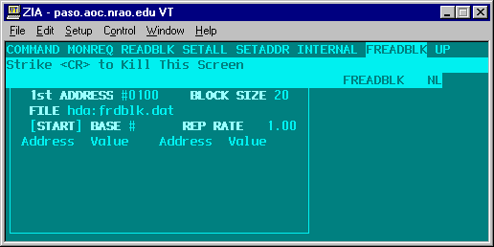
4. As an example let’s monitor the Vacuum of the drive. The MCB monitor address for vacuum on drive #1 is 2364H and the returned signal is in .1” of water, (the MCB address for drive #2 is 2B64H) Enter the following information. Block size is the number of data points per read. Rep Rate is in seconds.

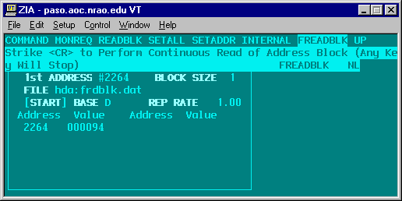
3.5.1
5. Start the FREADBLK using the START button. FREADBLK will append the file “had:frdblk.dat” once per second for ever. Remember to stop FREADBLK.

6. To up-load the data use WS_FTP95LE an FTP program available from your local computer division. Select the proper site and FTP the file “had:frdblk.dat” to your local hard disk.

7. Import the data into EXCEL to plot.

3.5.2

Data Logging Playback Drives using V47C

- Load the tape, INIT, LOAD, and setup the drive for operation.

- From the Operator Console enter the following two lines:
HostAdd “filehost-gwz”,”146.88.2.13”
NfsMount “filehost-gwz”,”/home”,”/users”
These commands mount a temporary disk on V47C.

3. Select MCB/FREADBLK,

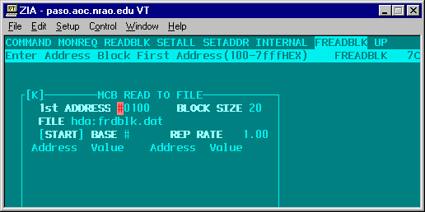
- As an example let’s monitor the Vacuum of drive #6. The MCB monitor address for vacuum on drive #6 is 6364H and the returned signal is in .1” of water. Enter the following information. Block size is the number of data points per read. Rep Rate is in seconds.

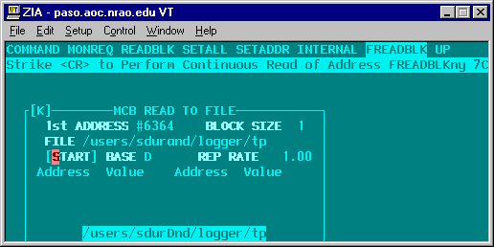
3.5.3

The Base address for each of the 24 playback drives is shown in the following table.

Drive Number | Base Address in HEX | Transport Board Address
 |  | (Odd Word Parity)
1 | 22 | 2A
2 | 2B | 2B
3 | 60
4 | 61
5 | 62
6 | 63
7 | 64 | 64
8 | 65 | E5
9 | 66 | E6
10 | 67 | 67
11 | 68 | 68
12 | 69 | E9
13 | 6A | EA
14 | 6B | 6B
15 | 6C | EC
16 | 6D | 6D
17 | 6E | 6E
18 | 6F | EF
19 | 74
20 | 75
21 | 76
22 | 77
23 | 78
24 | 79

5. Start the FREADBLK using the START button. FREADBLK will append the file “/users/sdurand/logger/tp” once per second forever. Remember to stop FREADBLK. Other users may want to specify a different file name in their user area.

6. To up-load the data use WS_FTP95LE an FTP program available from your local computer division. Select the proper site and FTP the file ““/users/sdurand/logger/tp” to your local hard disk.

7. Import the data into EXCEL to plot.
3.5.4
Procedure for Calibration with Calibration Tape for Test on VLA Recorders

Version 14
August 22, 2000

- Clean the tape path and mount the Calibration Tape.

- Load the tape, (INIT, LOAD). Print the present RECPARM.

- Select head 18 (Type RP 18)

- Bring up the RECPARM screen and set the LVDT positive and negative scale factors to 1000. Press the SEND button to send the parameters to the recorder. Or type PARM 4 1000 and PARM 5 1000. Calculate new inchworm speed parameters now, ENTER, SEND.

- Find track 18 by moving the headstack to a position of 125 and peaking on it by moving the tape forward. (Type MOVEA 125, SP 160, FOR and PEAK 200) Use a speed of 160 ips for the whole procedure. Record the position of track 18. Then position the tape to 1500 ft, POS 1500.

- Move the headstack by -400 and select head 19 (Type MOVEREL -400 and type RP 19, FOR).

- Peak the headstack to find track 18 with head 19 (Type PEAK 50). Record the position reading track 18 with head 19 as V19.

- Position the tape to 1500 ft. (use the POS 1500 command)

- Move the headstack to the position found for track 18 in step 5. (use the MOVEA ____command) Select head 17 (RP 17 17) and MOVEREL 400.

- Move the tape forward and immediately peak the headstack on track 18 with head 17 (PEAK 50) Record this position as V17

- Position the tape back to 1500 ft. (use the POS command) Move the head to the position found for track 18 in step 5.

- Select head 18 and move the tape forward and immediately peak on track 18. (PEAK 10). Record the position as V18.

- Calculate the new LVDT scale factors.

3.6.1
A. LVDT POS = (698.5 / (⏐V18 - V17⏐)) * 1000

B. LVDT NEG = (698.5 / (⏐V18 - V19⏐)) * 1000

- Enter the LVDT scale factors in the RECPARM screen and SAVE and SEND.

Determine the 160 ips Forward and Reverse Offsets

- Move the headstack to a position of 100 by MOVEA.

- Determine the inchworm speed parameters by pressing GO in the inchworm screen. Enter these new speed parameters in the RECPARM screen and press the send button. For better performance enter numbers into the RECPARM screen that are 3-5% larger than the inchworm sub-routine produces.

- Move the headstack to the position of track 18 by using this formula.

V18 *(LVDT POS / 1000) MOVEA ____

- Select track 18, RP 18.

- Run the tape in the forward direction and constantly PEAK 10 on track 18. Record each position.

- When the tape stops run the tape in the reverse direction. Constantly PEAK 10 on track 18 and record the position.

- Calculate the forward 160-ips offset: Use the readings taken in step 20 when the tape was running in the forward direction. Find the midpoint between the lowest and highest reading. Subtract 248 from the reading. Multiply this number by 10 and enter it in the RECPARM screen under FOR FST.

- Calculate the reverse 160-ips offset: Use the readings taken in step 21 when the tape was running in the reverse direction. Find the midpoint between the lowest and highest reading. Subtract 248 from the reading. Multiply this number by 10 and enter it in the RECPARM screen and under REV FST.

- Save the new parameters in the RECPARM screen and send them to the tape recorder.

- Go back and make sure it is where it should be by typing INDEX 1 248, MOVEF 1 in the forward direction and MOVER 1 in the reverse direction.

- Post-pass and unload the tape. Print the new RECPARM and file

3.6.2

Determine the Offsets at 40 ips and 80 ips

- Load a tape with enough blank space to record one forward pass and one reverse pass, about 6000 ft. INIT and LOAD. This should initialize the recorder with the proper RECPARM.

- Move the head to the fourth forward pass. MOVEF 4. Record the actual head position

- Setup the formatter to record.

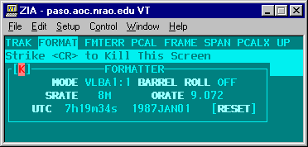

- Setup Recorder to record. EN 1111 and BYPASS. In the FORMAT, TRAK screen set ON/OFF to FFFFFFFF
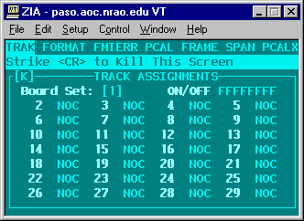
3.6.3

- Set the speed to 160 ips, SP 160. Position the tape to2000 ft, POS 2000.
- In the forward direction record at 160, 80, and 40 ips. Start the tape FOR. Record until 4000 feet. Change the speed to 80 ips, SP 80. Record until 6000 feet. Change speed to 40 ips, SP 40. Record until 8000 feet.
Feet | Speed
2000
 | 160 ips
4000
 | 80 ips
6000
 | 40 ips
8000
- Move the head to the fourth reverse position, MOVER 11. Record the actual head position
- In the reverse direction record at 40, 80, and 160 ips. Start the tape REV and a speed of 40 ips, SP 40. Record until 6000 feet. Change the speed to 80 ips, SP 80. Record until 4000 feet. Change speed to 160 ips, SP 160. Record until 2000 feet. Stop the tape, STOP.
Feet | Speed
8000
 | 40 ips
6000
 | 80 ips
4000
 | 160 ips
2000

3.6.4

- Disable the write, type EN 0000, POS 2000, READ and RP 18 18. Move the head to the fourth forward head position, MOVEF 4. Set the speed to 160 ips, SP 160. Start the tape, FOR. Peak on the track, PEAK 10. Peak every 300 feet and record the actual position of the forward-160-ips. At 4000 feet peak over a wider range, PEAK 50. Then PEAK 10 every 300 feet and record the actual position of the forward-80-ips. At 6000 feet peak over a wider range, PEAK 50. Then PEAK 10 every 300 feet and record the actual position of the forward-40-ips. At 8000 feet stop the tape, STOP.

forward-160-ips

forward-80-ips

forward-40-ips
If the forward-160-ips is not within +/- 3 microns of the MOVEF 4 value redo steps 15-26.
- Move the head to the fourth reverse head position, MOVER 11. Start the tape, REV. Peak on the track, PEAK 10. Peak every 300 feet and record the actual position of the reverse-4- ips. At 6000 feet peak over a wider range, PEAK 50. Then PEAK 10 every 300 feet and record the actual position of the reverse-80-ips. At 4000 feet peak over a wider range, PEAK 50. Then PEAK 10 every 300 feet and record the actual position of the reverse-160-ips. At 2000 feet stop the tape, STOP.

reverse-40-ips

reverse -80-ips

reverse -160-ips
If the reverse -160-ips is not within +/- 3 microns of the MOVER 11 value redo steps 15-26.
- Calculated the forward and reverse offsets.
3.6.5

Terms
FOR FST = the 160 ips forward offset that is entered into the RECPARM screen. Step 22
MOVEF 4 = the position the heads moves when MOVEF 4 command is used. Step 28
forward-80-ips = The actual the position the head finds the track. Step 35
FOR NML = the 80 ips forward offset that is entered into the RECPARM screen
FORHALF= the 40 ips forward offset that is entered into the RECPARM screen

FOR NML = FOR FST +{(10) X [(MOVEF 4) - (forward-80-ips)]}

REV NML = REV FST +{(10) X [(MOVER 11) - (reverse-80-ips)]}

FORHALF = FOR FST +{(10) X [(MOVEF 4) - (forward-40-ips)]}

REVHALF = REV FST +{(10) X [(MOVER 11) - (reverse-40-ips)]}

Enter the new offsets in the RECPARM screen.

38. Verify the offsets are correct. The RSCREEN package does not use the FOR NML, REV NML, FOR HALF, or REVHALF offsets. To use these offsets they need to be entered manually into the FOR FST and REV FST offsets.

3.6.6

Tape Loop Sensor Calibration

The supply and take up sensors in the vacuum columns each have two adjustments: gain and symmetry. The procedures in the following paragraphs explain how to make these adjustments. The attached drawing locates the adjustments and test points.

Preliminary Procedures

- Load a tape.

- Make sure vacuum setting is correct.

- Connect digital voltmeter between (bottom white blue lead) and (ground) black lead for the take up sensor, or between (top white blue lead) and black lead (ground for the supply sensor). See attached drawing.

Adjustment

1. Observe voltmeter while manually rotating the appropriate reel to move
tape completely into; then out of the column.

2. Repeat step (1) and adjust R7 to obtain a voltage difference of 1.5
( + 0.05) Vdc between the highest and lowest readings.

3. Repeat step (1) and adjust R3 to obtain a voltage reading of +0.9 (+0.05)
When tape is completely in column, and a voltage of –0.6 (+0.05) Vdc when tape is out of column.

4. Repeat steps (2) and (3) until desired setting is obtained.

5. Repeat procedure for take up sensor.

3.7.1

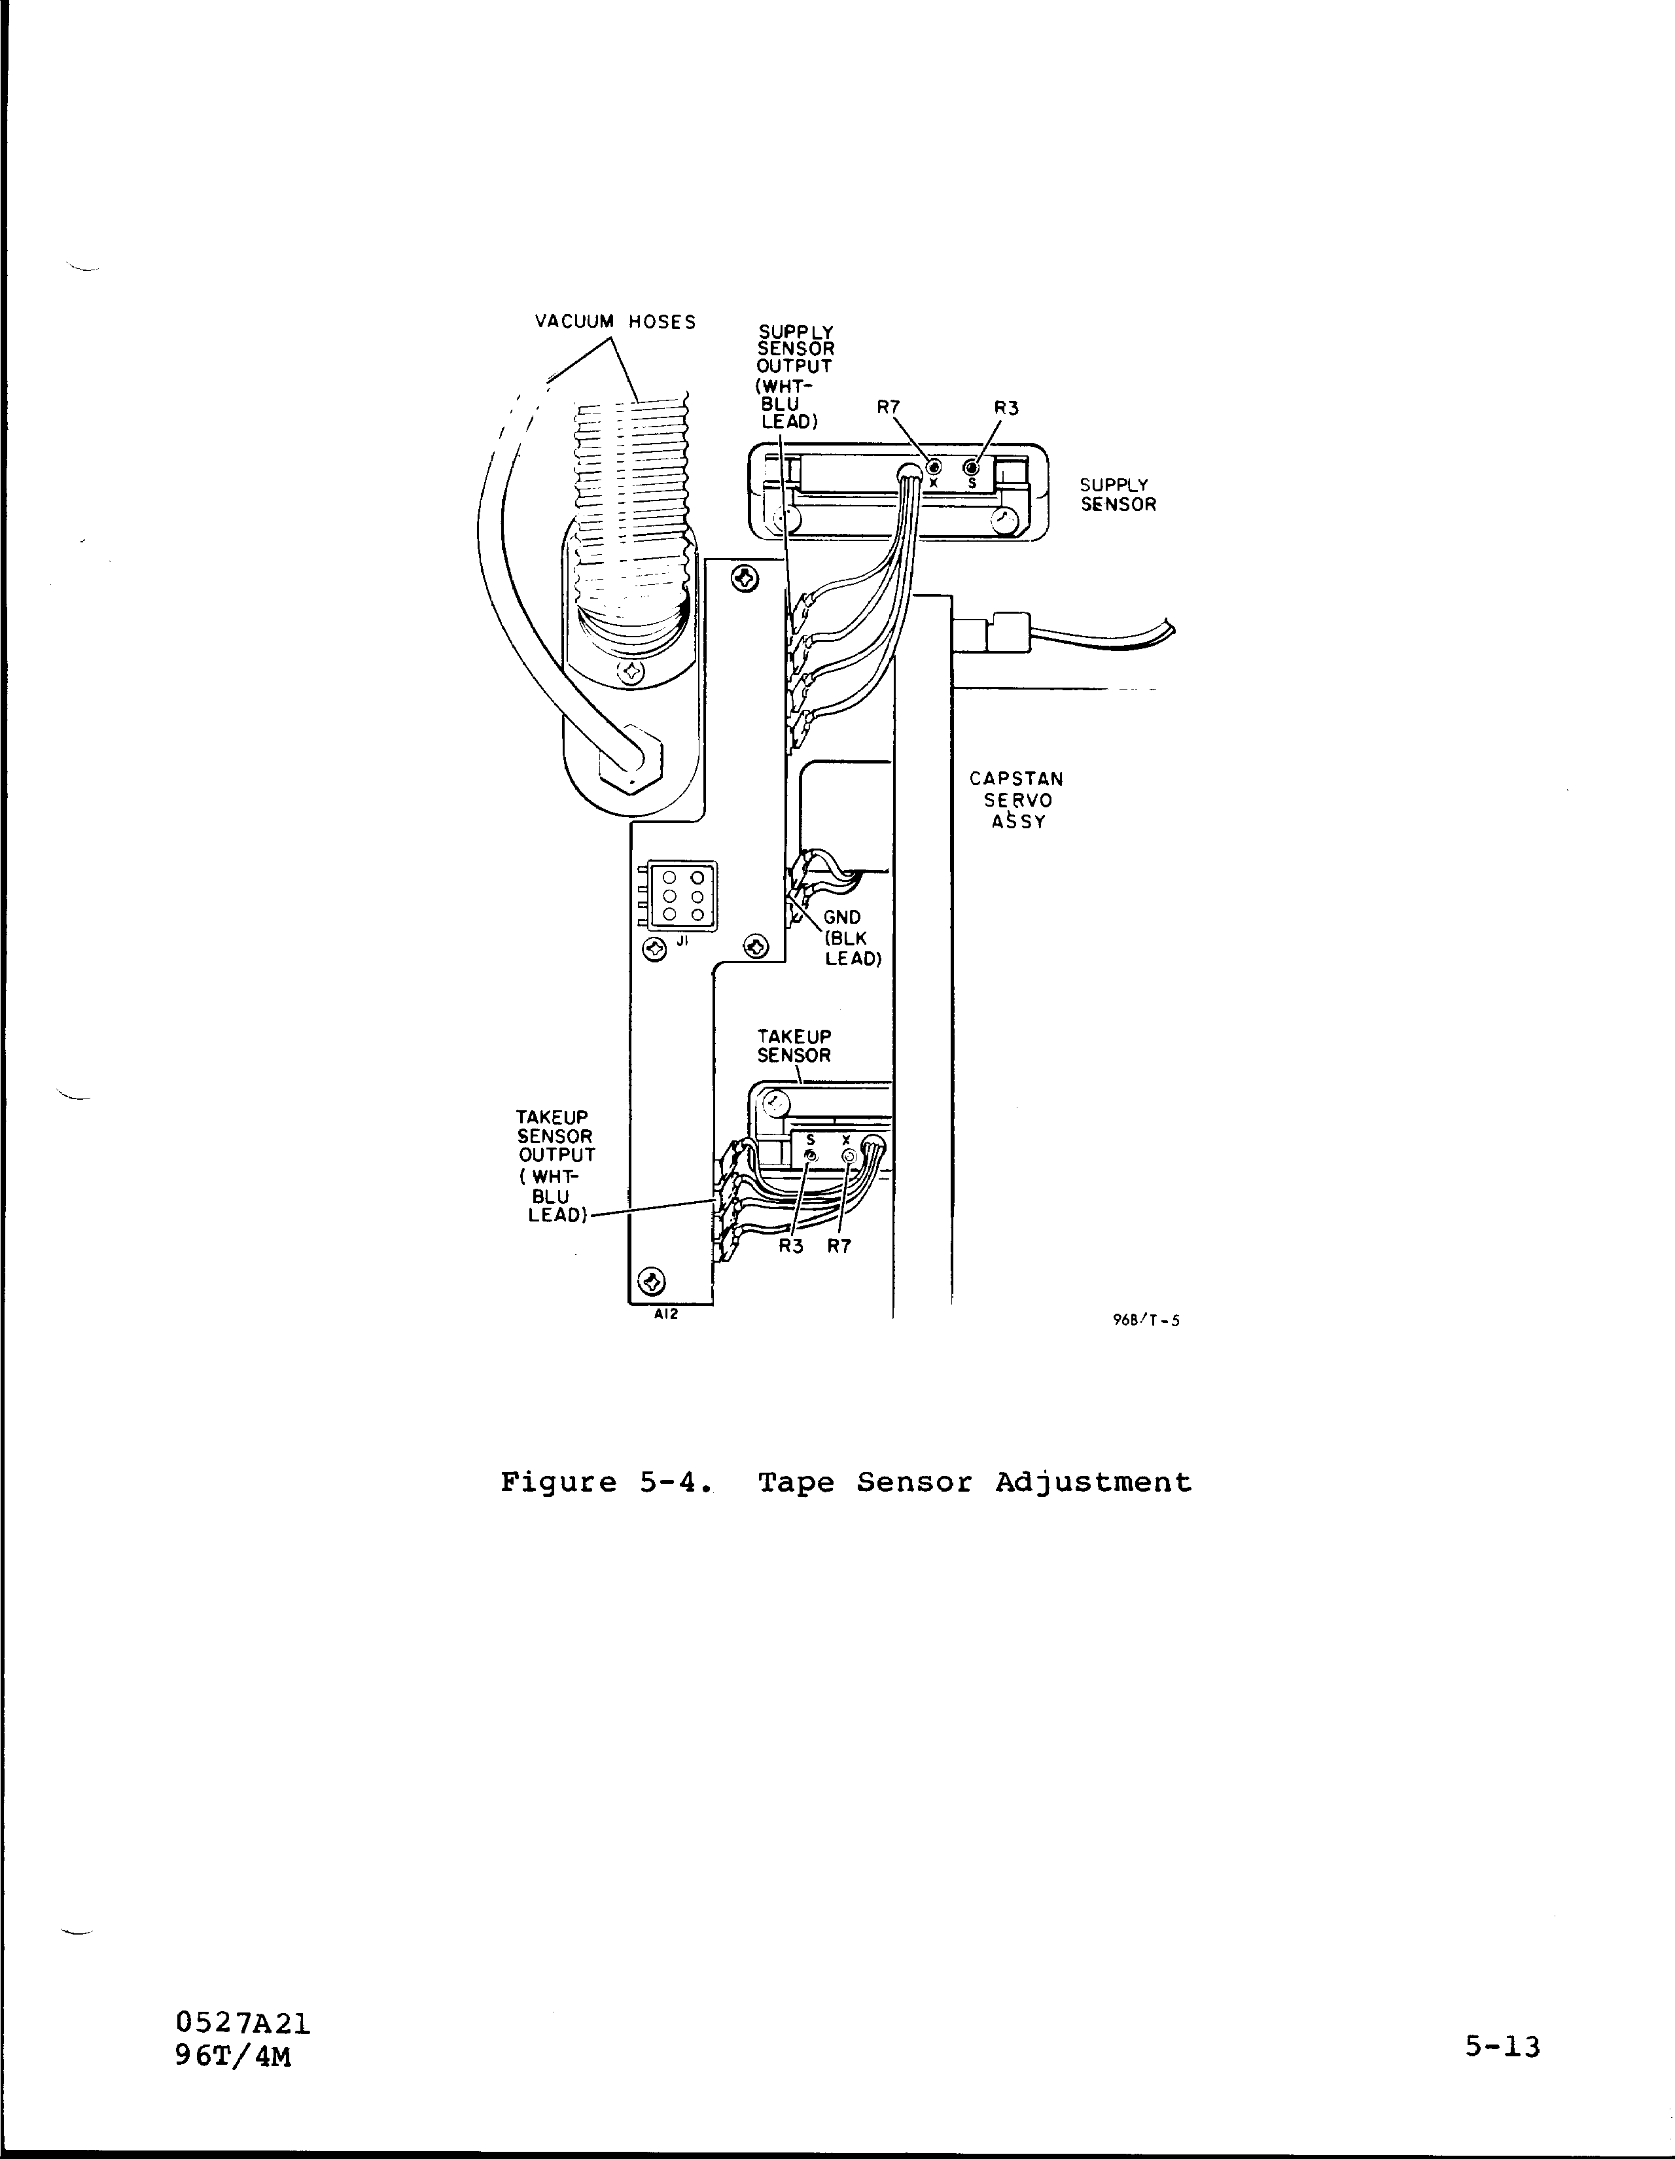
3.7.2

Calibration of the VLBA Recorder Vacuum Sensor

The VLBA Recorder has a computer readable vacuum sensor, which must be calibrated for each VLBA Recorder. Once the calibration has been determined, an accurate reading of the vacuum pressure can be taken remotely.

- Bring up the TDCCMD screen, and load the tape by typing LOAD. Use the MONREQ screen to be sure that the addresses 22D5 and 22D6 contain 0. If they do not, use the COMMAND screen to send 0 to these addresses.

- Adjust the vacuum motor voltage until the vacuum gauge on the back of the recorder reads EXACTLY 7.5 inches of water. To adjust the vacuum, type VACUUM 3.54, for example, to set the vacuum motor to 3.54 volts.

- Read address 2257 with the MONREQ screen. Take the number that is displayed in decimal, and divide it by 204.8. This number is the voltage on the vacuum pressure sensor. Record this number as V_{7.5} for the voltage corresponding to 7.5 inches of water. Use 2 digits after the decimal point, and round the last digit up or down.

- Follow steps 2 and 3 for readings of 10 and 11.5 inches of water.

- Calculate the slope. Slope = 40/(V_{11.5} – V_{7.5}).

- Calculate the Y intercept. Y intercept = 100 – (slope * V_{10.0}).

- Enter the slope and intercept on the RECPARM screen. Round to the nearest whole number. Enter the numbers in decimal, using a “-“ sign before negative numbers. Save the parameters to the disk by hitting the SAVE button, and send the parameters to the tape recorder by hitting the SEND button, or by typing INIT in the TDCCMD screen after the parameters have been saved to the hard disk of the station computer.

3.8.1

VLBA Tape Format and Recording Modes

The following details of the VLBA longitudinal tape format are taken from VLBA document A56000N003 (VLBA Longitudinal Track Format, J. D. Romney, 1990 November 16) with some clarification (G. Peck, private communication). For additional information on sampling and recording modes supported by the Very Long Baseline Array, see the documents Basic VLBA Recording Modes, R. C. Walker, 1993 January 20 and Standard VLBA Observing Modes, J. D. Romney, 1993 January 27 (both available at ftp.aoc.nrao.edu).Longitudinal Format

Longitudinal Data Format

The VLBA standard tape format is illustrated in Figure C-1. The primary differences compared to the Mark IV tape format are:
1. The VLBA uses non-data-replacement tape frame; that is, the time, sync and auxiliary data are spliced into the data stream instead of replacing a small amount of data as in Mark IIIA and Mark IV. This increases the frame length by 160 bits + 20 parity bits compared to the Mark IIIA/IV frame.
2. The auxiliary-data field is considered to be at the end of the tape frame, so that frame-specific parameters within the aux-data must be referred to the data field immediately prior to the aux-data field.
3. The encoding of the time and aux-data are somewhat different and are detailed below.

Time Code & CRC

The VLBA Time code spans eight bytes (48 bits), organized as 12 BCD digits, designated T1-T12, plus a two-byte (16 bit) CRC error-detection pattern. All BCD digits in the time-code field are written to tape in the order msb-to-lsb. There are three sub-fields in the time-code field:

3.9.1

MJD - Modified Julian Date

The three least-significant digits of the Modified Julian Date, as defined in Section B of the “Astronomical Almanac”:
J (T1) MJD (100’s digit)
J (T2) MJD (10’s digit)
J (T3) MJD (1’s digit)

Seconds
The time interval elapsed since the beginning of the given MJD, expressed in seconds to a precision of 0.1 milliseconds. An implicit decimal point follows the unit seconds digit at T8:
S (T4) Seconds (10000’s digit)
S (T5) Seconds (1000’s digit)
S (T6) Seconds (100’s digit)
S (T7) Seconds (10’s digit)
S (T8) Seconds (1’s digit)
s (T9) Seconds (0.1’s digit)
s (T10) Seconds (0.01’s digit)
s (T11) Seconds (0.001’s digit)
s (T12) Seconds (0.0001’s digit)

CRC
A “CRC-16” cyclic redundancy code is computed on the data bits (not including parity bits) of the first six time code bytes, using the generating polynomial x¹⁶+x¹⁵+x²+1 (initialized to zero). The 16-bit output is written to the final two bytes of the 64-bit Time Code field.

Auxiliary Data

The VLBA auxiliary data comprises eight bytes (64 bits) organized as 16 BCD digits. All BCD digits in the aux-data field, unless stated to be bit-reversed, are written to tape in the order msb-to-lsb. Bit-reversed digits are written in order of lsb-to-msb. The ranges shown are appropriate to current plans for the VLBA recording system. The auxiliary data field can be written as 16 BCD digits of 4-bits each.

3.9.2
SSRHPPPPTGBSCD00
These 16 digits are also referenced as A1 through A16, in order from left to right, and written onto tape in the same order, except that each of the digits ‘TGBSCD’ are bit-reversed (i.e. written lsβ®msb; indicated by underscore). The auxiliary parameters can begrouped into four logical sub-fields:

Station Identification - A unique identification code assigned to each station
S (A1) Station Code (10’s digit)
S (A2) Station Code (1’s digit)

Recorder Parameters - Recorder and Headstack which wrote this track (though current VLBA implementation uses only single headstack), and sign and magnitude of the absolute headstack position commanded for that headstack
R (A3) Recorder# 0 - 1
H (A4) Headstack# 0
P (A5) Position Sign 0:+ 8:-P
(A6) Position (100’s digit)
P (A7) Position (10’s digit)
P (A8) Position (1’s digit)

DAR Parameters - Data-acquisition rack (‘D-rack’) parameters; all digits in this sub-field are bit-reversed. Parameters marked ‘BR’ change every frame as a result of barrel roll.
T (A9) Track 0 - 7 (see Appendix A)
G (A10) Group 0 - 4 (see Appendix A)
B (A11) Bit 7 (BR) 0: ‘Magnitude’ bit1: ‘Sign’ bit
S (A12) Sideband (BR) 0: lower 1: Upper
C (A13) Converter (BR) 0 - 7 (corresponding to BBC’s 1-8, respectively)
D (A14) DAR# 0 - 1 (currently only single DAR)
A15 0
A16 0

Sync Word

The VLBA sync word is identical to the Mark IIIA and Mark IV sync word (see Section 2.1.3).

Data Field

The VLBA Data Field is very similar to the Mark IV Data Field, with the following points to be noted:
- The first bit of the VLBA Data Field has a sample-time corresponding exactly to the immediately-preceding Time Code. Since the format is non-data-replacement, the last bit of the VLBA Data Field (assuming no fan-in/fan-out is active) has a sample-time corresponding to one-sample-period before the next Time Code field.
- Sample encoding is identical to Mark IV sample encoding (see Section 2.1.4).
- Optional pseudo-random-code modulation of the Data Field is identical to Mark IV (see Section 2.1.4).

3.9.3

Transverse Data Format
The VLBA transverse format is essentially identical to the Mark IV, except that:, in addition to the 32 heads per headstack supported by Mark IV, the VLBA formatter support 4 additional heads called ‘system tracks’. The 36 available heads are labeled 0-35, with the center 32 heads (2-33) corresponding to the 32 heads of a Mark IV headstack. The VLBA ‘system tracks’ are intended to serve as additional support tracks for such things as spares and cross-track parity.

Barrel Roll Conventions
‘Barrel-Rolling’ is the periodic reassignment of bit streams to tracks in a cyclic pattern. The purpose of barrel-roll is to minimize susceptibility to a bad head or bad track by spreading the data over many tracks.

For purposes of barrl-rolling, the 32 formatter ‘data’ outputs 8 (2-33) are divided into 4 groups of 8 outputs or 2 groups of 16 outputs. At each frame, the barrel-roll steps to the next step in the barrel-roll sequence; the barrel-rolling sequence is reinitialized on every
even second mark. Formatter ‘system’ outputs (0-1 and 34-35) are not barrel-rolled. The block diagram of the VLBA formatter Figure 1 may help to clarify the available internal data paths.
Though the barrel-rolling capability of the VLBA formatter is very flexible, only a simplified subset of possible barrel-rolling modes is normally used. The following guidelines (George Peck, personal communication) have been adopted by the VLBA in assigning barrel roll modes:

- Barrel roll is disabled if the total number of tracks is not divisible by 8.
- The 8-track barrel-roll is an 8-step sequence that is enabled when −
• the total number of tracks is divisible by 8 but not by 16, OR
• the tape-writing rate is ≤ 2 Mbits/sec/track and the total number of tracks is divisible by 16.

By VLBA convention, 8-track barrel-roll implies the sequence where 2→4, 4→6, ..., 16→2; 3→5, 5→7, ..., 17→3; 18→20, 20→22, ..., 32→18; 19→21, 21→23, ..., 33→19; etc. The barrel-roll is incremented on every frame, and reset (restarted) on every even second mark.

- The ‘16-track’ barrel-roll is a 16-step sequence that is enabled when
• the total number of tracks is divisible by 16
• tape writing speed is ≥ 4 Mbits/sec/track.

3.9.4
The details of the standard VLBA 16-track barrel-roll sequence for even tracks is given in Table 8.

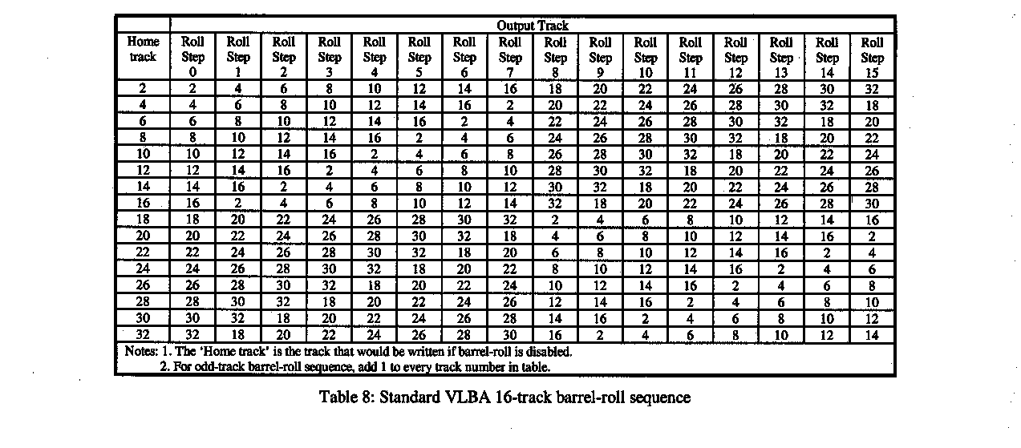

Cross Track Parity
The VLBA formatter can form cross-track parity on groups of 8 or 16 formatter ‘data’ outputs and direct these (post barrel-roll) cross-track-parity data streams to the formatter ‘system’ outputs. In particular, cross-track parity from ‘8-track’ groups 2-9, 10-17, 18-25 and 26-33 may be written to any of the formatter ‘system’ outputs 0,1,34 or 35. Additionally, cross-track parity from ‘16-track’ groups 2-17, 10-25 and 18-33 may be written to any of the formatter ‘system’ outputs. The purpose of the cross-track parity data streams is to compensate for the loss of a single track of data within the group of tracks protected by the cross-track parity. This use of this feature has been designed into the VLBA correlator, but the author is unaware of its use to date.

Data-Multiplex (Fan-In/Fan-Out) Format
Although the VLBA formatter has extreme flexibility in the selection of fan-out track assignment, simple conventions have been adopted for standard recording modes, as outlined below. The user may arbitrarily assign any BBC-sideband to any CHANNEL. Special fan-out track assignments for special modes are not necessarily precluded.

Data-Multiplex Track-Assignment Conventions

The fanout conventions adopted by the VLBA are given in the tables below. For fan-out modes, the bit ordering for a single data stream is from the top to the bottom of an individual column in a table.

3.9.5
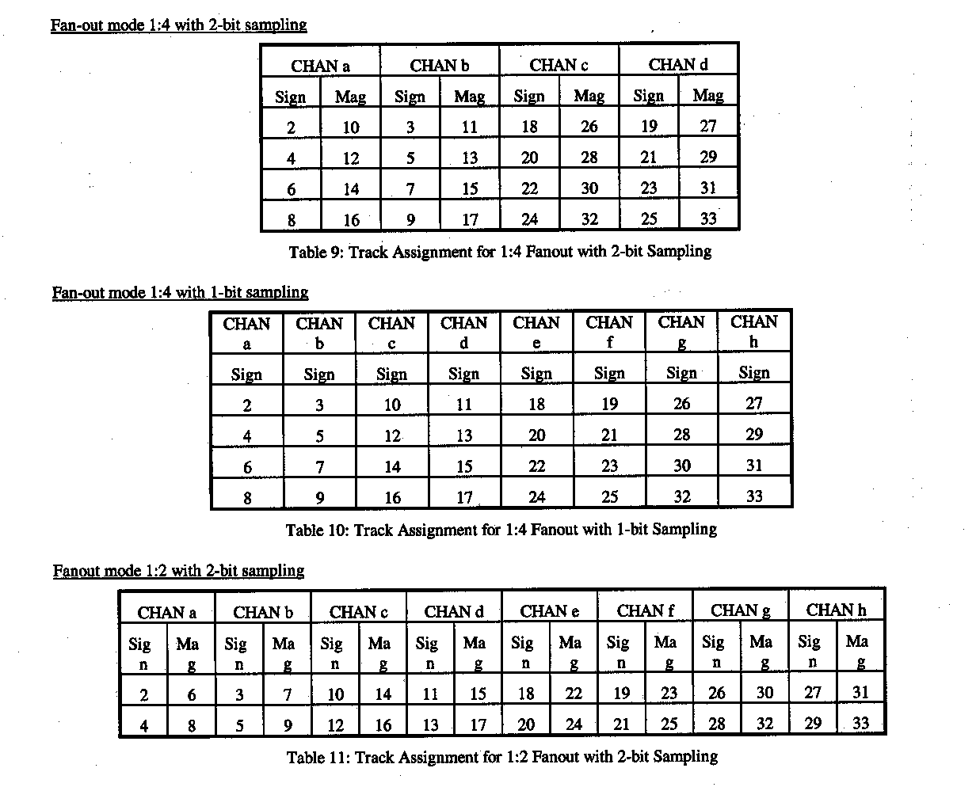
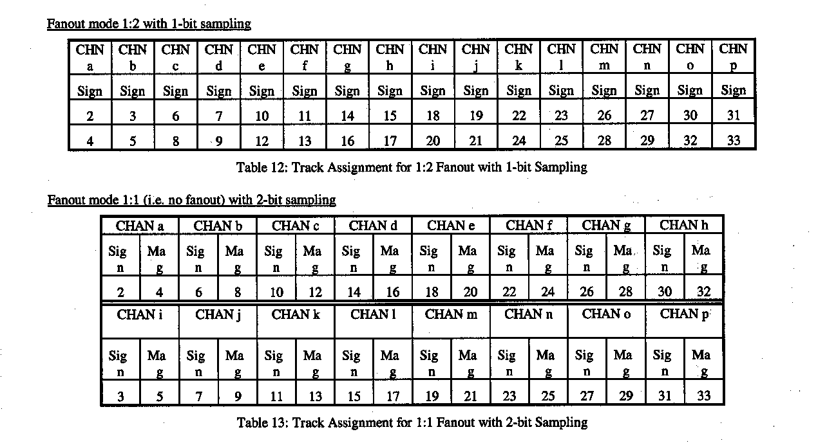

3.9.6
Fanout mode 1:1 (i.e. no fanout) with 1-bit sampling

This mode is essentially the Mark IIIA-compatible mode with 1 channel/track. Typically, 16 even tracks are recorded in one tape direction and 16 odd tracks in the other tape direction to emulate the standard Mark IIIA recording modes (see Appendix B).
Notes:
1. A ‘channel’ may be any USB or LSB output from any BBC.
2. For each multiplexed channel, the sample bit taken at the Time Code+0 is written as the first bit in the Data Field of the lowest-numbered track; the sample bit taken at Time Code+1-sample-period is written as the first bit in the Data Field of the lowest-numbered-track+2, etc.

Fan-In Track-Assignment Conventions

As of this writing, fan-in track-assignment conventions have not yet been stated by NRAO. Fan-in modes are not yet supported by the VLBA correlator.

Recorder Characteristics

Transport

The VLBA transport is mechanically identical to the Mark IV transport, although the control electronics has been significantly modified. Control of the VLBA system is with the MCB (Monitor and Control Bus).

Headstack

The VLBA uses a single headstack which is identical to the Mark IV headstack (see Section 2.3.2) except that all 36 heads are supported. The headstack can be electronically switched between read and write capability.

Headstack Positioner

The VLBA headstack positioner is identical to the Mark IV headstack positioner (see Section 2.3.3).

Physical Recording-Format Conventions

Longitudinal
Like the Mark IV, the longitudinal bit density along a track is determined entirely by the writing data rate and the tape speed. Although the design density of the VLBA system is ~56,250 bpi/track, operations are currently being done at ~33,000 bpi/track. Since the maximum per-track-data-rate of the VLBA system is ~9 Mbits/sec, all recording modes can be supported at ~33,000 bpi. Note that the recording speed must be slightly different for the ‘data-replacement’ and ‘non-data-replacement’ formats in order to keep the longitudinal density constant. Plans currently exist to increase the density to ~56,000 sometime in 1996. 3.9.7

Transverse

The design specification for the VLBA is 16 passes of the tape writing all 36 tracks. Currently, the VLBA is operating in a 14-pass mode (i.e. 14 passes with all 36 head writing on each pass), with the possibility to upgrade to a 16-pass mode in the future. Figure 4 illustrates the layout of recorded tracks across the tape for the ‘14-pass’ operating mode. This mode requires that the headstack be positioned to 14 different positions in such a way that there is non-interference between adjacent tracks. Seven of the positions are recorded in the forward direction, spaced at 48 um; with a 38 um track width; this provides a 10 um guard band between these tracks. The forward-tape-motion headstack positions have been chosen to be -319, -271, -223, -
175, -127, -79 and -31um (by convention, negative headstack positions are away from the transport deckplate; headstack position ‘0’ is calibrated to center the headstack on the tape). This can be visualized as a group of seven adjacent parallel stripes on the tape all written by the same head.
This group of seven stripes is widely separated from the group written in the same-tape-motion-direction by adjacent heads; the space in between, as explained in the next paragraph, is for a group of seven tracks written in the reverse-motion direction.

The reverse-tape-motion headstack positions are also chosen with a spacing of 48um; in particular, the headstack positions are 31, 79, 127, 175, 223, 271 and 319 um. This groups the reverse-direction tracks written by head n into seven parallel stripes straddled on the positive-headstack-position side by the forward-written tracks laid down by the head n and on the negative-headstack-position side by the group of seven parallel tracks written in the forward direction by head n-1. Note that the forward-motion group of tracks is separated from the reverse-direction group of tracks by 24 um (track edge to track edge), providing a larger guard band 14 um larger between the forward/reverse track groups than between tracks within the same group. The recognizes the fact that the forward-direction/reverse-direction tracking signature of the transport is generally poorer than repeatability in the same tape-motion direction.

Note that multiple passes may be written at the each headstack position (in the same tape-motion direction) so long as exclusive sets of heads are recorded on each pass.

3.9.8

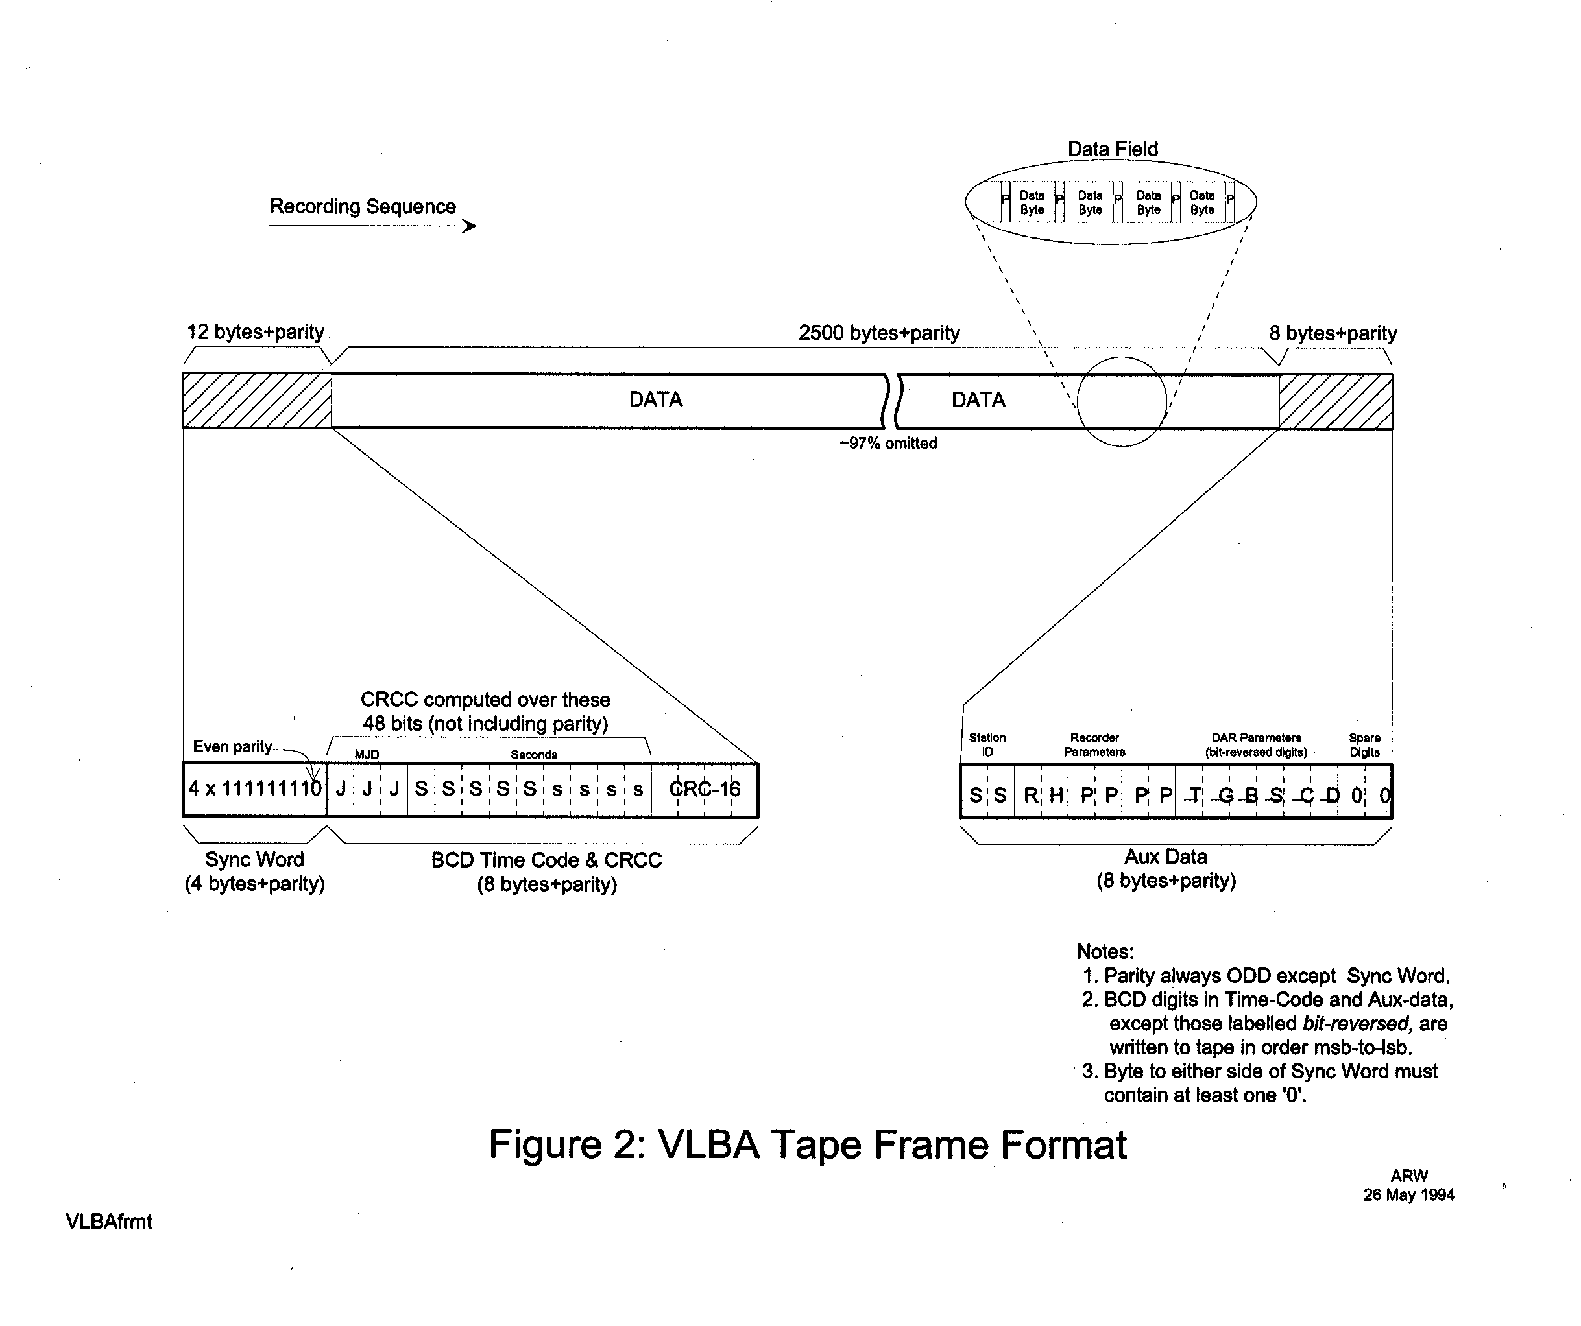
3.9.9
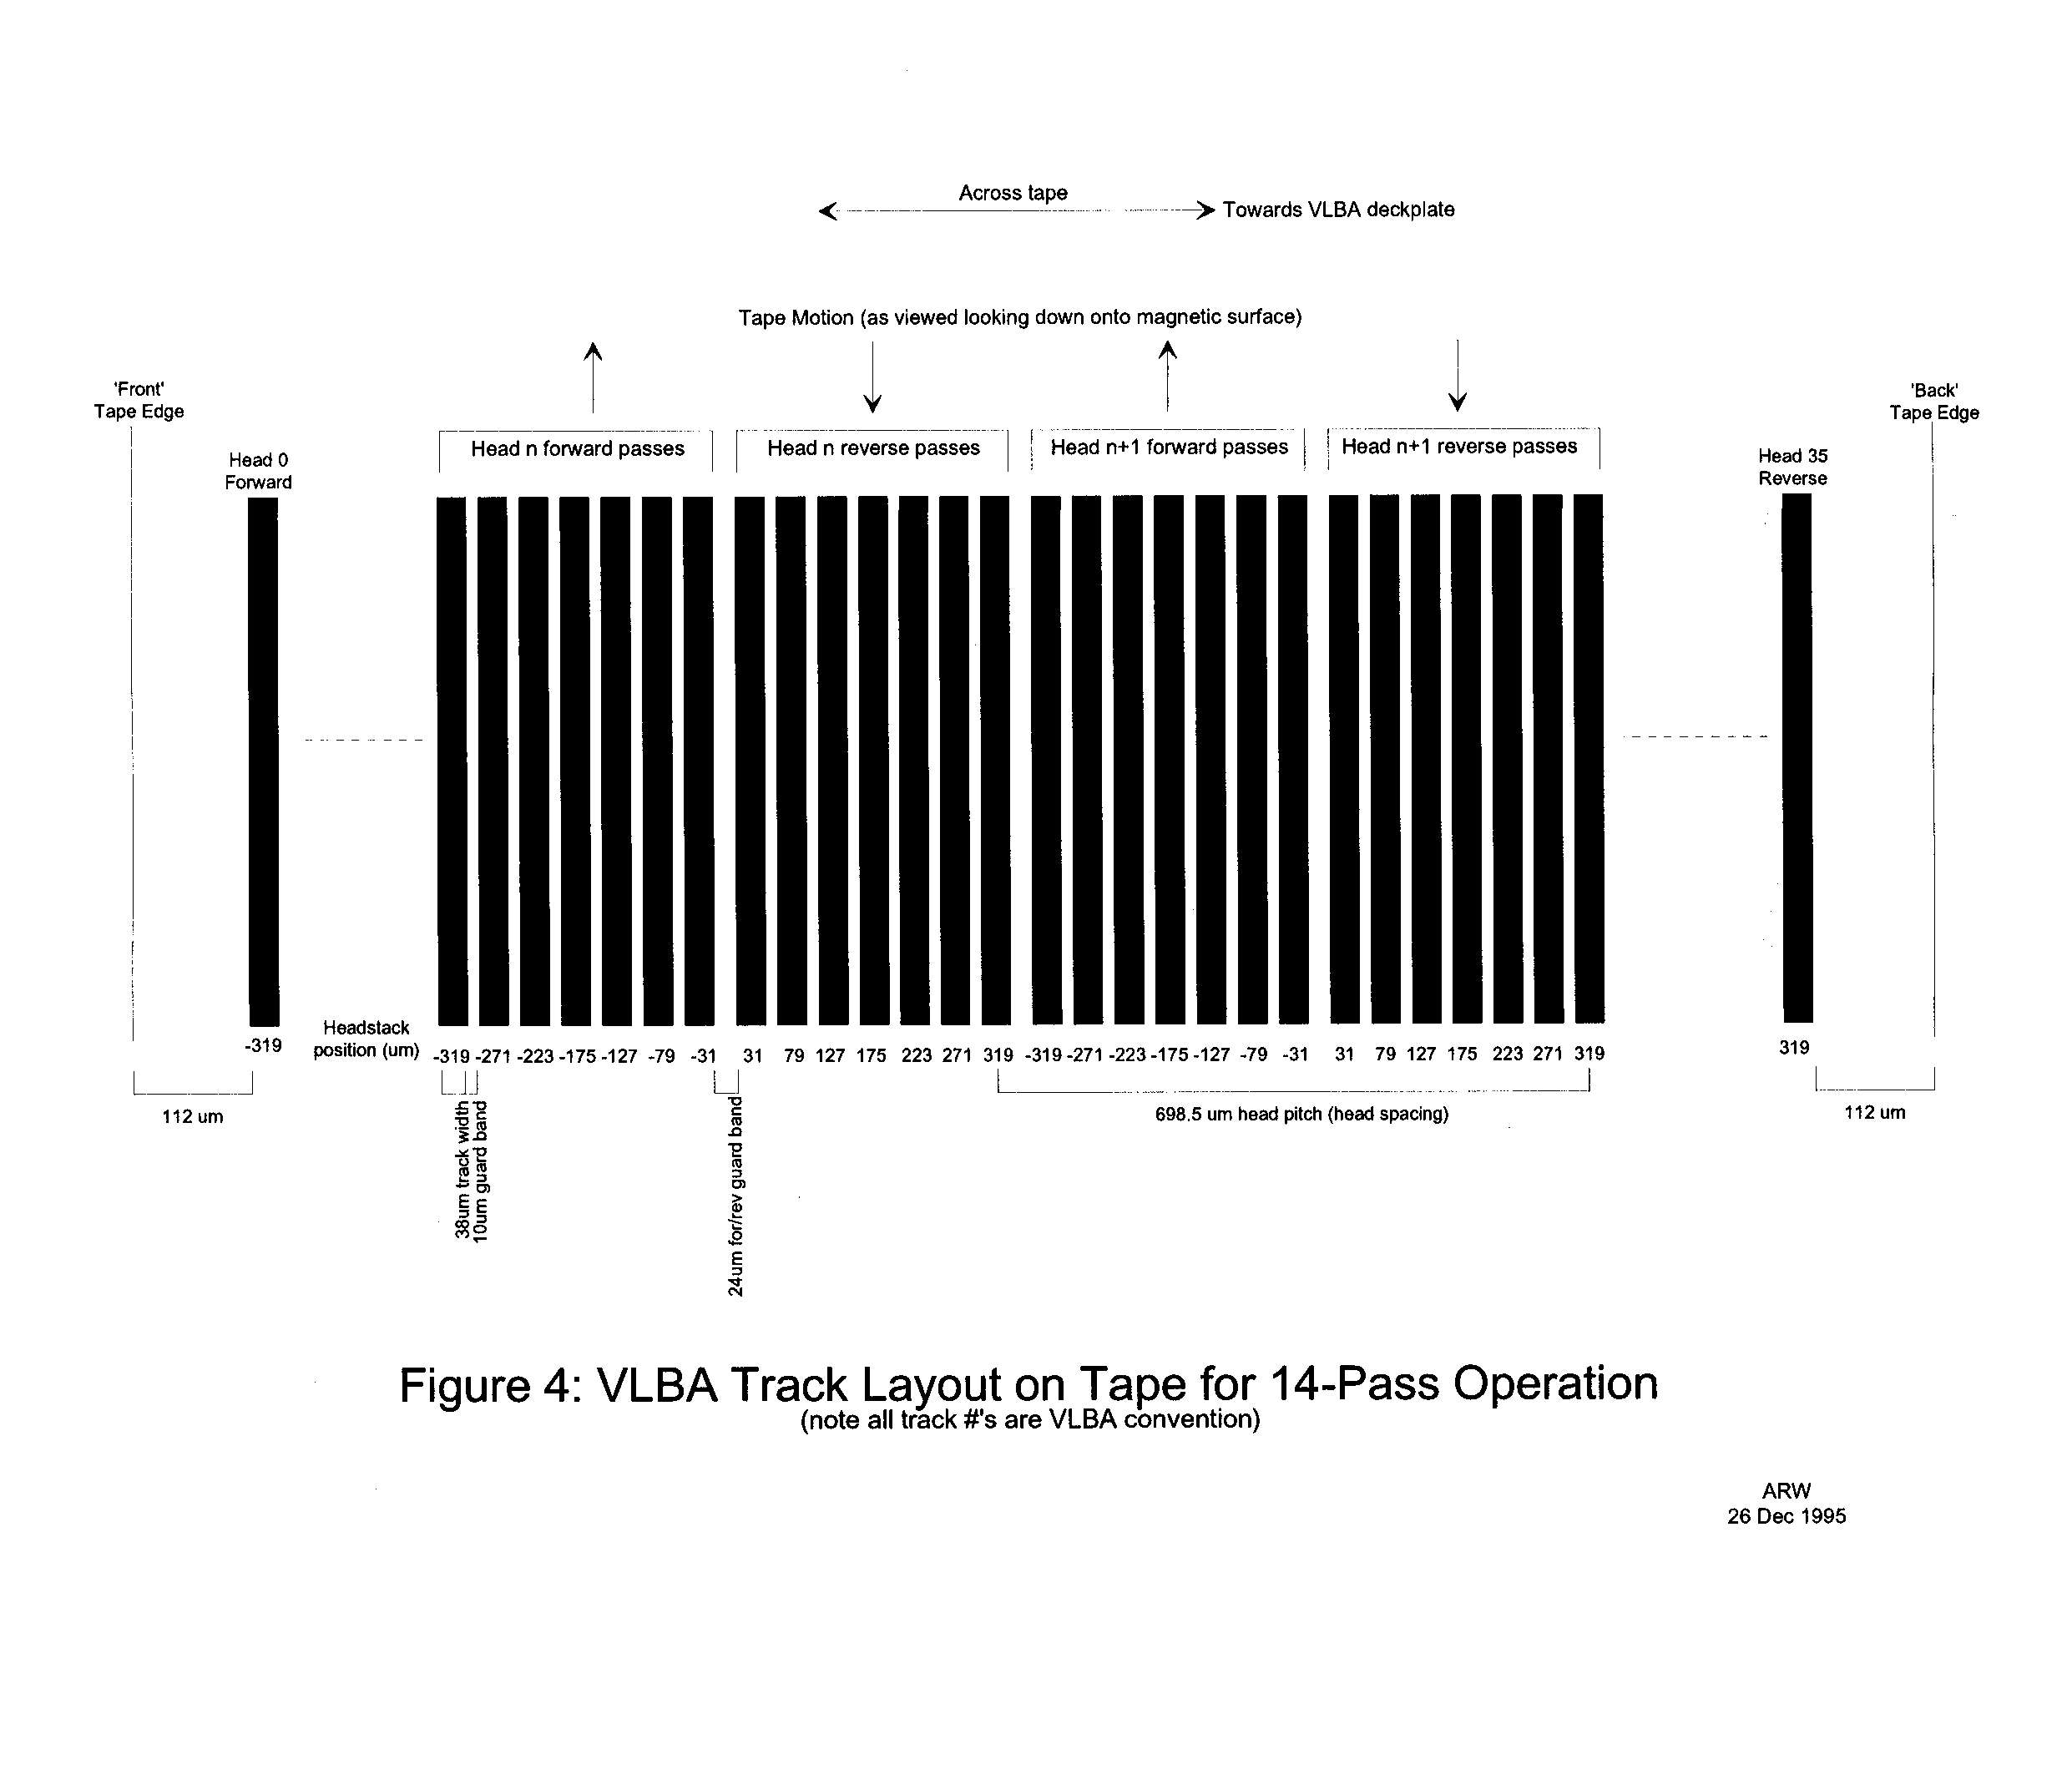

3.9.10

