Data Acquisition Memo 403
S. Durand
D.Gerrard

Sampler QA Procedure

Version 3
February 2004
Introduction:
This procedure is to test the Sampler Module (D121) to insure that it operates correctly.

Procedure:

- Setup:

  - Install the test card (c) on the 40-pin connector of the sampler to be tested. Make sure that pin one of the cable from the test card mates up with the sampler pin one of the 40-pin connector on the rear of the sampler.

  - Install a module extender card and attach the sampler module using the extender support rod and remove the panel on the opposite side with the 40 pin connector.

Measure the Reference Voltages

  - Refer to Figure 1 for a layout of the sampler and Figure 2 for test point locations.
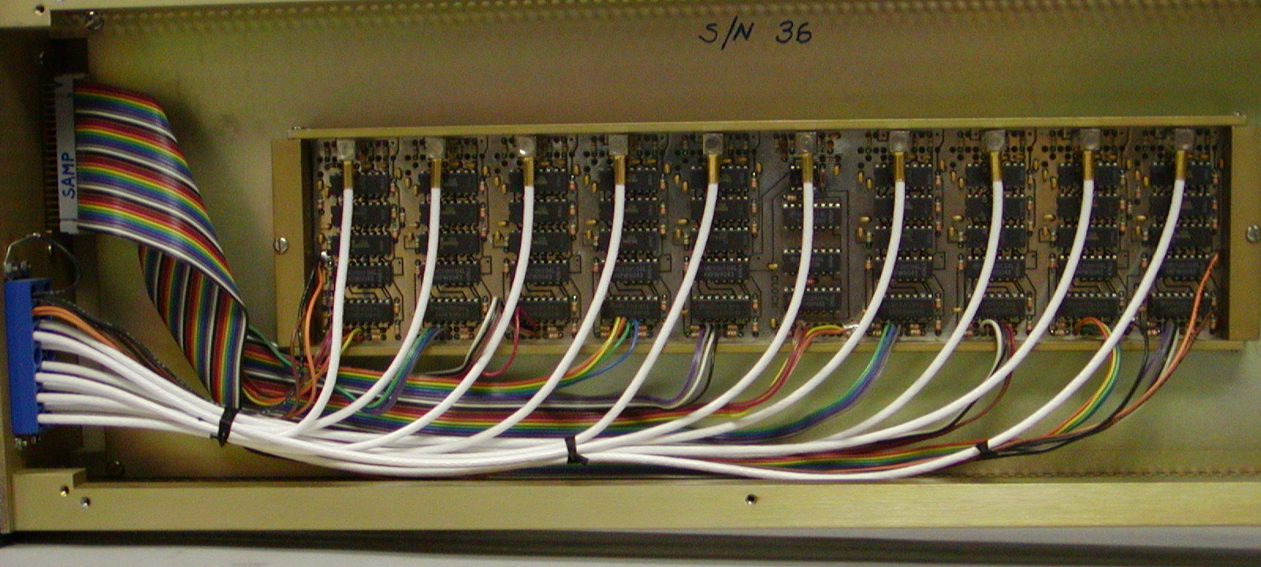

Photograph showing the inside of the sampler.

Measure and Record the reference voltages with a Voltmeter. There are three AD96885 amplifiers in each bank of samplers. A dc reference is supplied to pin 4 (the inverting input) of each amplifier. The voltages are referred to as follows; threshold high (T_{H} = +200 mV), threshold low (T_{L} = –200 mV), and the middle threshold (T_{M} = 0 mV). Only the Sync (group #0) has T_{M} = 94 mV.

 | T_{H} = 200 mV ± 5 mV | T_{M} = 0 mV ± 3 mV | T_{L} = – 200 mV ± 5 mV
Group # 0 |  | *
Group # 1
Group # 2
Group # 3
Group # 4
CLK
Group # 5
Group # 6
Group # 7
Group # 8

*T_{M} = 94 mV ± 3 mV for Group 0 (Sync) only.

Testing using a reference tone

  - Configure a BBC that is not connected to the sampler being tested to supply a 10 KHz tone for the input to the IF distributor using the following steps.

    - Select a Base Band Converter (BBC) not connected to the sampler being tested as the reference source by connecting its front panel LO output to IF Distributor A external input 1 with a coaxial cable.
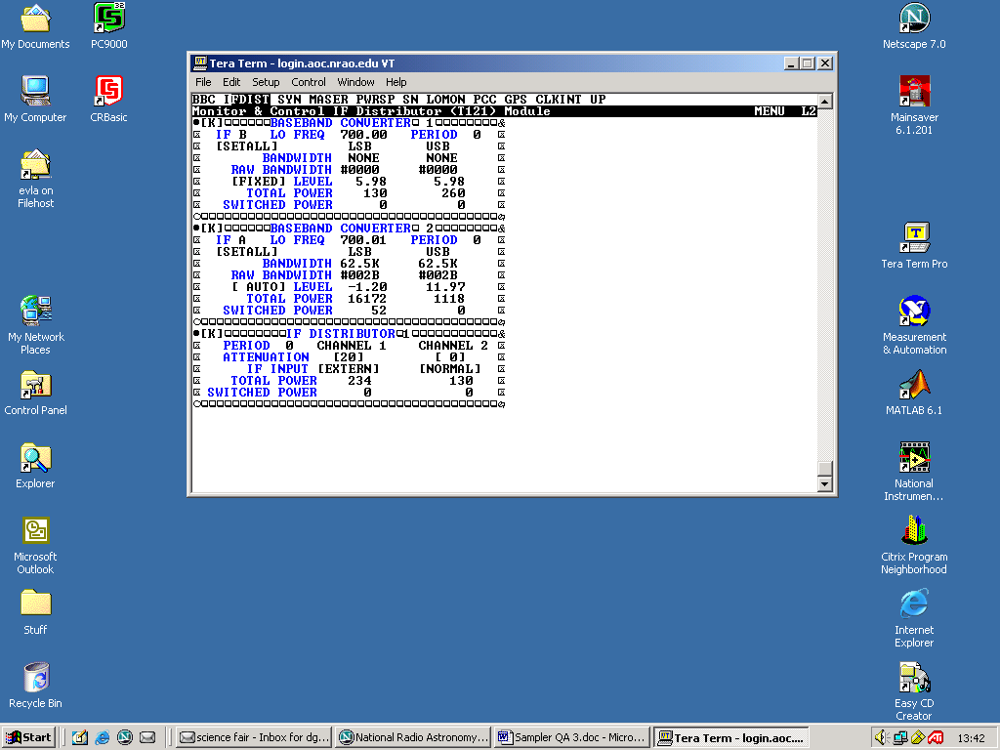
    - Using SCREENS, set the BBC LO output to 700.00 MHz and select IF to B.

    - Set IFA input to EXTERN and IF A attenuation to 20 db.
    - Establish a 10 KHz signal on each Lower Side Band (LSB) on the BBC’s connected to the sampler being tested output by setting:
      - the LO Frequency to 700.01 MHz,
      - IF to A,
      - LSB and USB Bandwidth to 62.5 KHz, and
      - gain control to AUTO level.

Note: (700.00 MHz – 700.01 MHz = 10 KHz LSB.) For this setup, Auto level will seek a low value (around – 2 db) that will AGC the BBC total power output to about 16,000 counts.

  - Connect scope to the LSB + and LSB – test points on the test board corresponding to the BBC input signal and record the step voltages in the table below.

  - Set the LO of the BBC generating the signal to 700.02 MHz. This will generate a 10 KHz signal out of the USB outputs of BBCs being tested. Check USB test points for this signal.

 | -130 mV  ± 5 mV | -180 mV  ± 5 mV | -230 mV  ± 5 mV | -280 mV  ± 5 mV
Sync
USB1
LSB1
USB3
LSB3
USB2
LSB2
USB4
LSB4

  - Verify the frequency and wave shape at the test points on the ladder resistor network is similar to Figure 3. Verify each upper and lower side band for each BBC output.

- Testing the Sampler using the Digital Switch and PCALX Counters

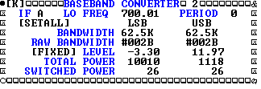
  - With the IF distributors and BBC’s set up from part C, fix the Level so that the Total Power counts can be adjusted on the four BBC’s going to the sampler being tested.
Chan # Sideband BBC # Type Convention
0 lower 1 magnitude 1 lm
1 lower 1 sign 1 ls
2 upper 1 magnitude 1 um
3 upper 1 sign 1 us
4 lower 2 magnitude 2 lm
5 lower 2 sign 2 ls
6 upper 2 magnitude 2 um
7 upper 2 sign 2 us
8 lower 3 magnitude 3 lm
9 lower 3 sign 3 ls
10 upper 3 magnitude 3 um
11 upper 3 sign 3 us
12 lower 4 magnitude 4 lm
13 lower 4 sign 4 ls
14 upper 4 magnitude 4 um
15 upper 4 sign 4 us
16 lower 5 magnitude 5 lm
17 lower 5 sign 5 ls
18 upper 5 magnitude 5 um
19 upper 5 sign 5 us
20 lower 6 magnitude 6 lm
21 lower 6 sign 6 ls
22 upper 6 magnitude 6 um
23 upper 6 sign 6 us
24 lower 7 magnitude 7 lm
25 lower 7 sign 7 ls
26 upper 7 magnitude 7 um
27 upper 7 sign 7 us
28 lower 8 magnitude 8 lm
29 lower 8 sign 8 ls
30 upper 8 magnitude 8 um
31 upper 8 sign 8 us

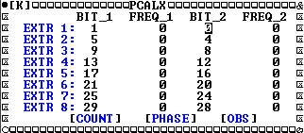
  - Run PCALX in the normal (two bit) mode by setting the extractors as shown to the right. Enter on Count.
  - This is an example of the PCALX output when the Level is set for AUTO (Power Level about –1) for BBC 2 on the lower side band. The counts are predominately in the 00 and 11 Bins.
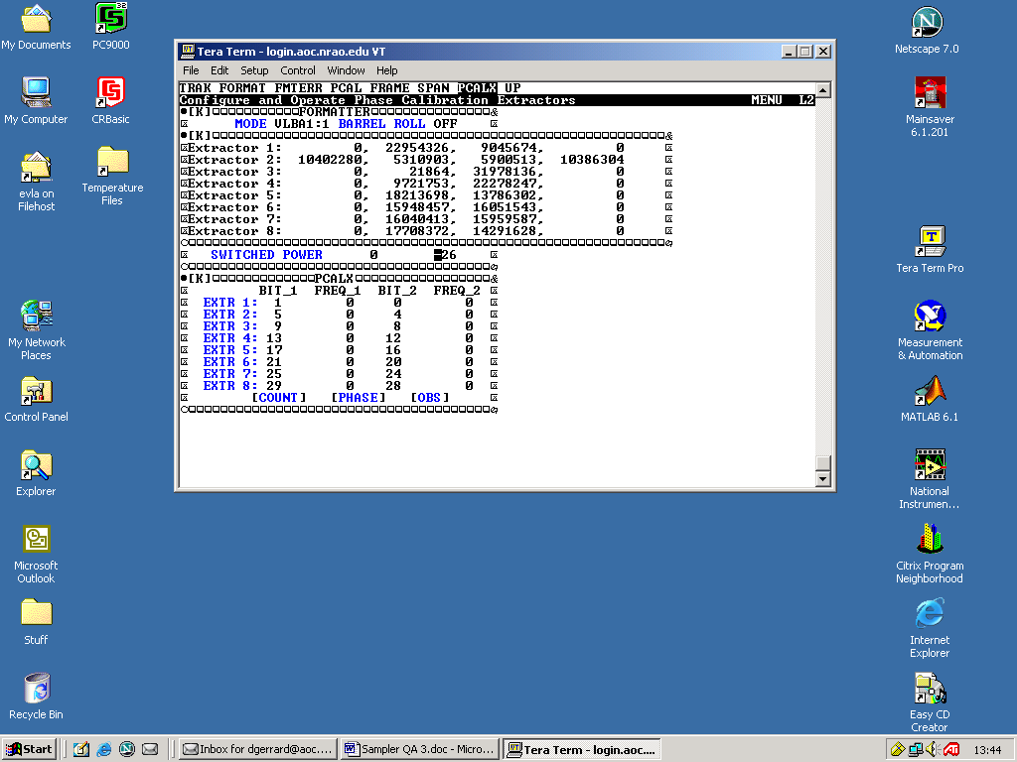
00011011

  - When the Level is fixed to about 10,000 counts (Power Level about –3) the counts are more evenly distributed between the bins.
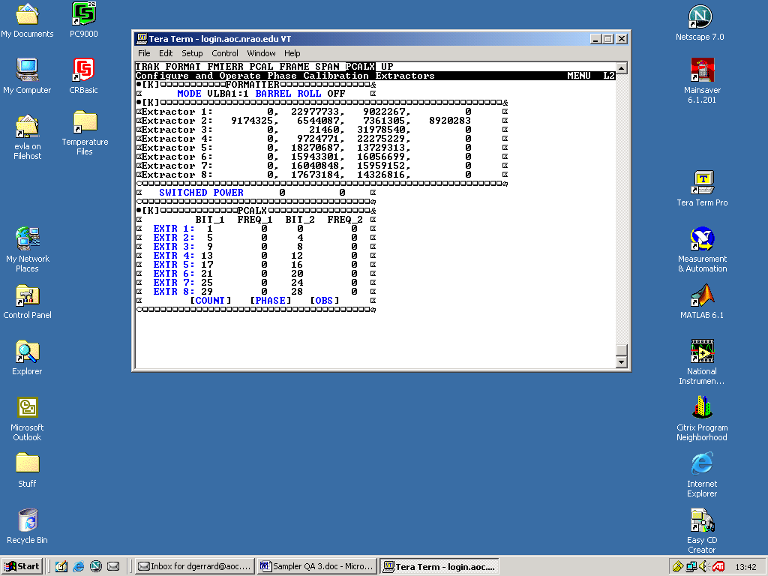
00011011

  - Finally, fixed the Level to about 6,000 counts (Power Level about –6). Now the Bins with the most counts are the 01 and 10 Bins.
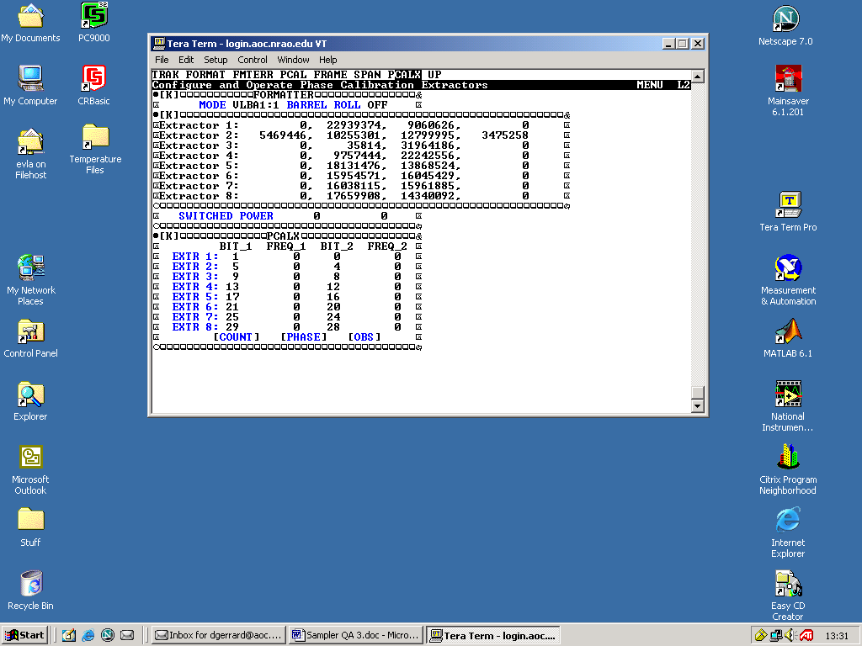
00011011

  - Note in this example, only BBC 2 was used on the lower side band. All four BBCs should be used on the LSB and then ran on the USB by changing the LO of the BBC generating the signal to 700.02 MHz and repeating the PCALX.

